Reading the figures.

* On the bottom row of each figure, there is a matrix whos elements represent the t-statistic from comparing pairs of conditions. The names of the conditions can be found on the row and column. Stars represent a significant difference and, if there is a difference, the t-value is shown .

# PVT Data Analysis

For this analysis, data from 11 subjects were used.

Same as those in the original analysis (out of the 12 subjects, only subject 8 was removed)

## Betweenness Centrality during PVT

### Figure 1a: Time course of **Betweenness centrality** after awakening WITHOUT blue light exposure

Notes

* Betweenness centrality across all frequencies remains unchanged after awakening in the control condition

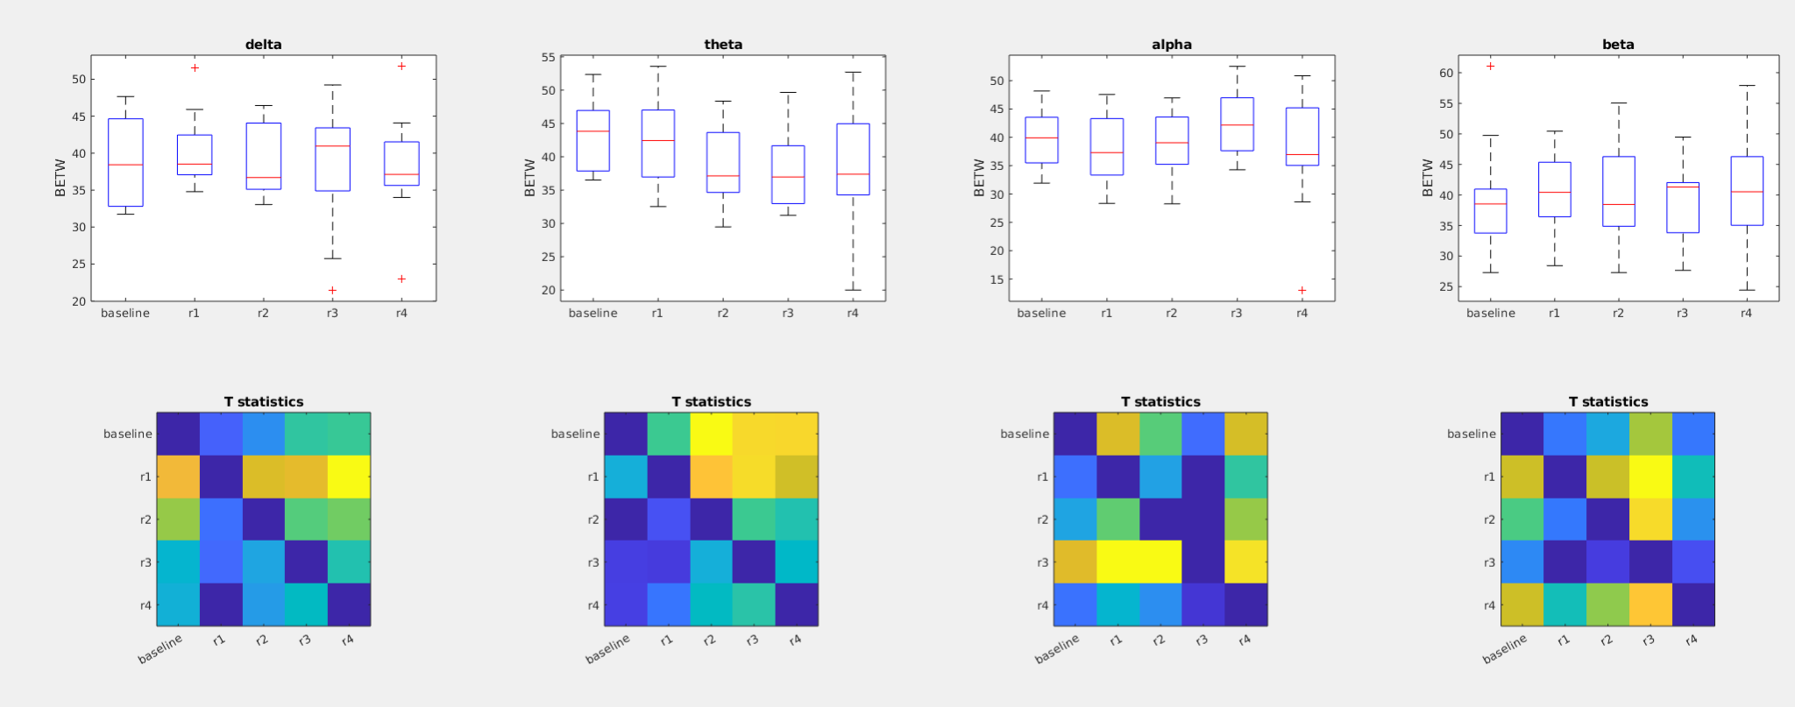

### Figure 1b: Time course **Betweenness centrality** after awakening **WITH** **Blue Light Exposure**

*Exposure to blue-light immediately after awakening reduces theta betweenness which reverts back to baseline within 30 minutes*

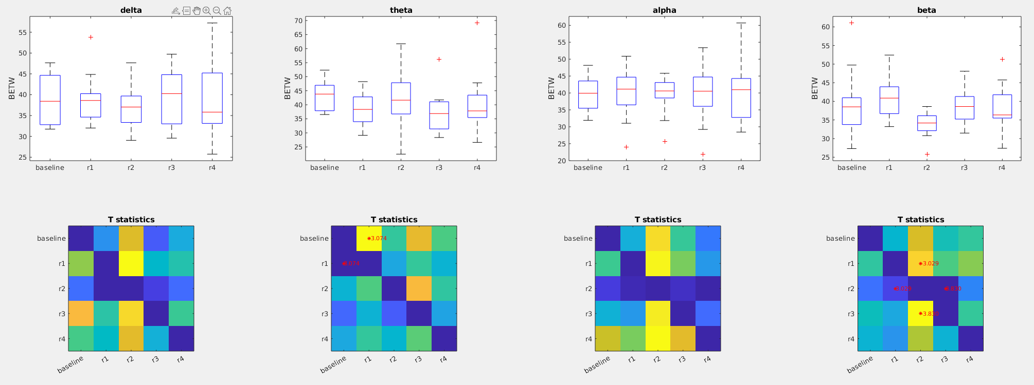

### Figure 1c: **Betweeness Centrality** during preseleep (**baseline**) Vs awakening WITHOUT light exposure (**control_R1**) vs Awakening WITH light exposure (**light_R1**)

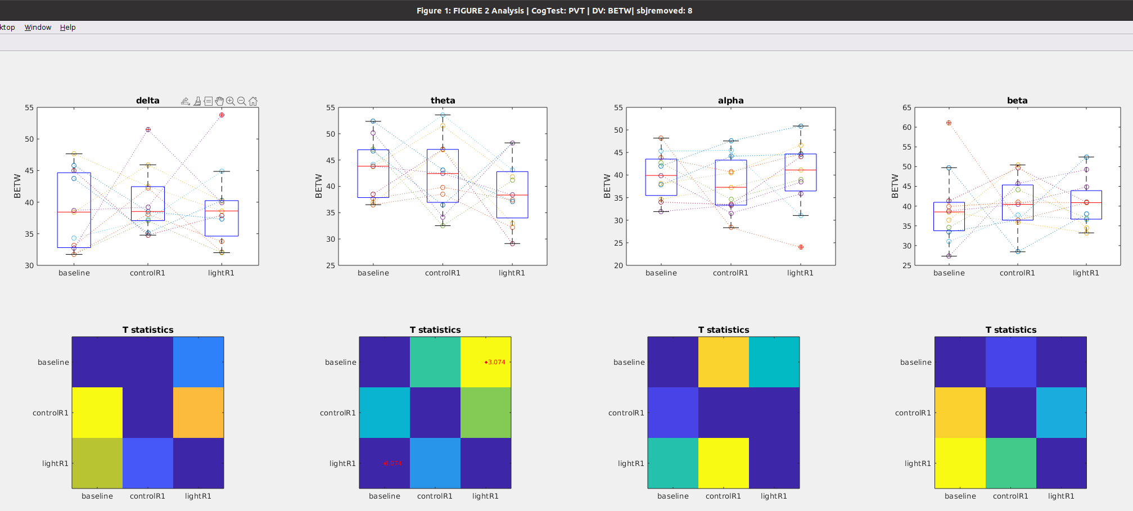

## WPLI during PVT

### Figure 2A: Time course of **WPLI** after awakening WITHOUT blue light exposure

*Under control conditions, Theta WPLI decreases about 30 minutes after awakening and does not recover within 45 minutes (the 4th test)*

*Under control conditions, there are no changes in delta, alpha and beta WPLI after awakening*

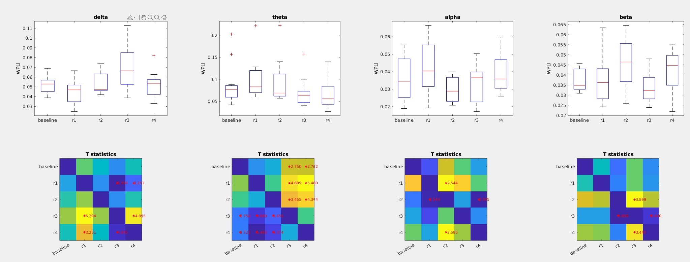

### Figure 2B: Time course of **WPLI** after awakening WITH **Blue-Light Exposure** (eeg data gathered during performance on PVT task)

*Blue light exposure increases WPLI in the delta band and does not recover back to baseline within 45 minutes (the 4th test) (see the first column)*

*Blue light exposure after awakening prevents changes in Theta WPLI (second column)*

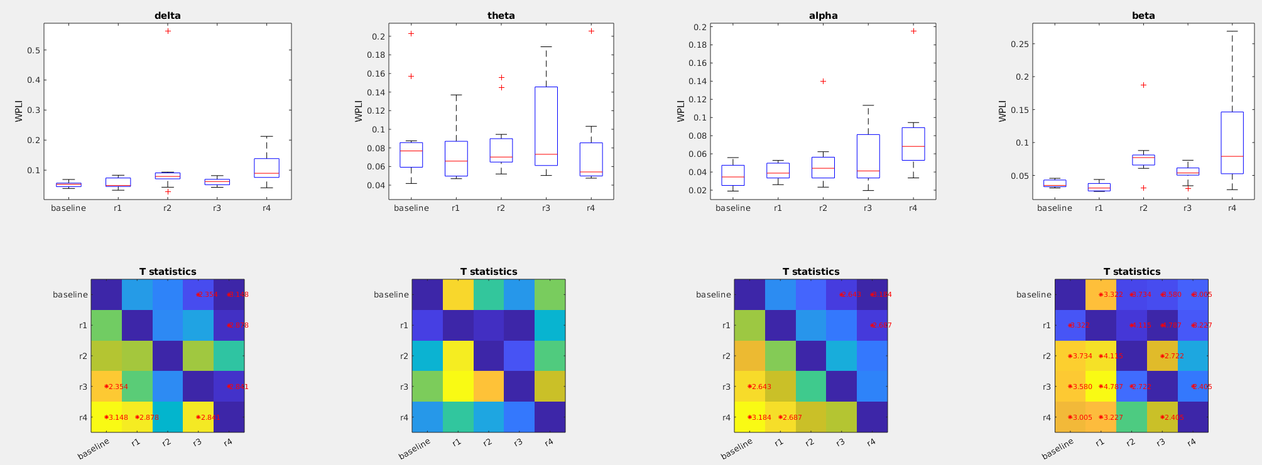

### Figure 2c: **WPLI** during preseleep (**baseline**) Vs awakening WITHOUT light exposure (**control_R1**) vs Awakening WITH light exposure (**light_R1**)

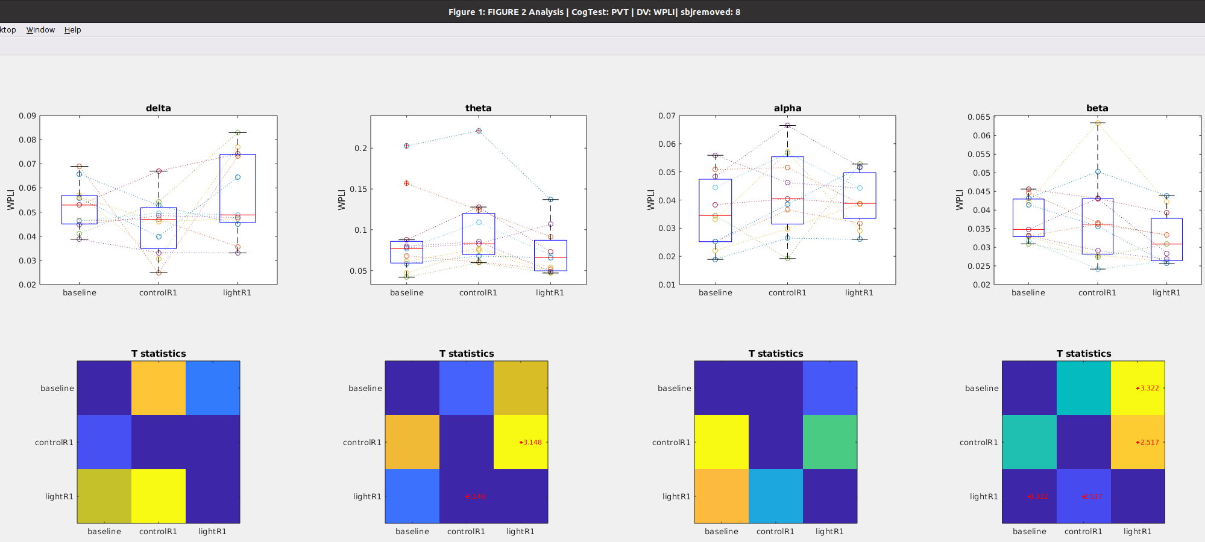

# KDT Task

Notes on Data Set

* For the KDT task, there was no data for the 12th subject
* Also note that for this analysis I dropped subject 7 because of no baseline data

## Global Power during KDT

### Figure 3a: Time course of **global** after awakening **WITHOUT** blue light exposure

Notes

* No changes in delta band (1st column) or theta band (2nd column)
* Late onset reduction in alpha band (3rd column)
* Immediate reduction in beta band (4rth column)Furthermore, there was no data for the 12 subject

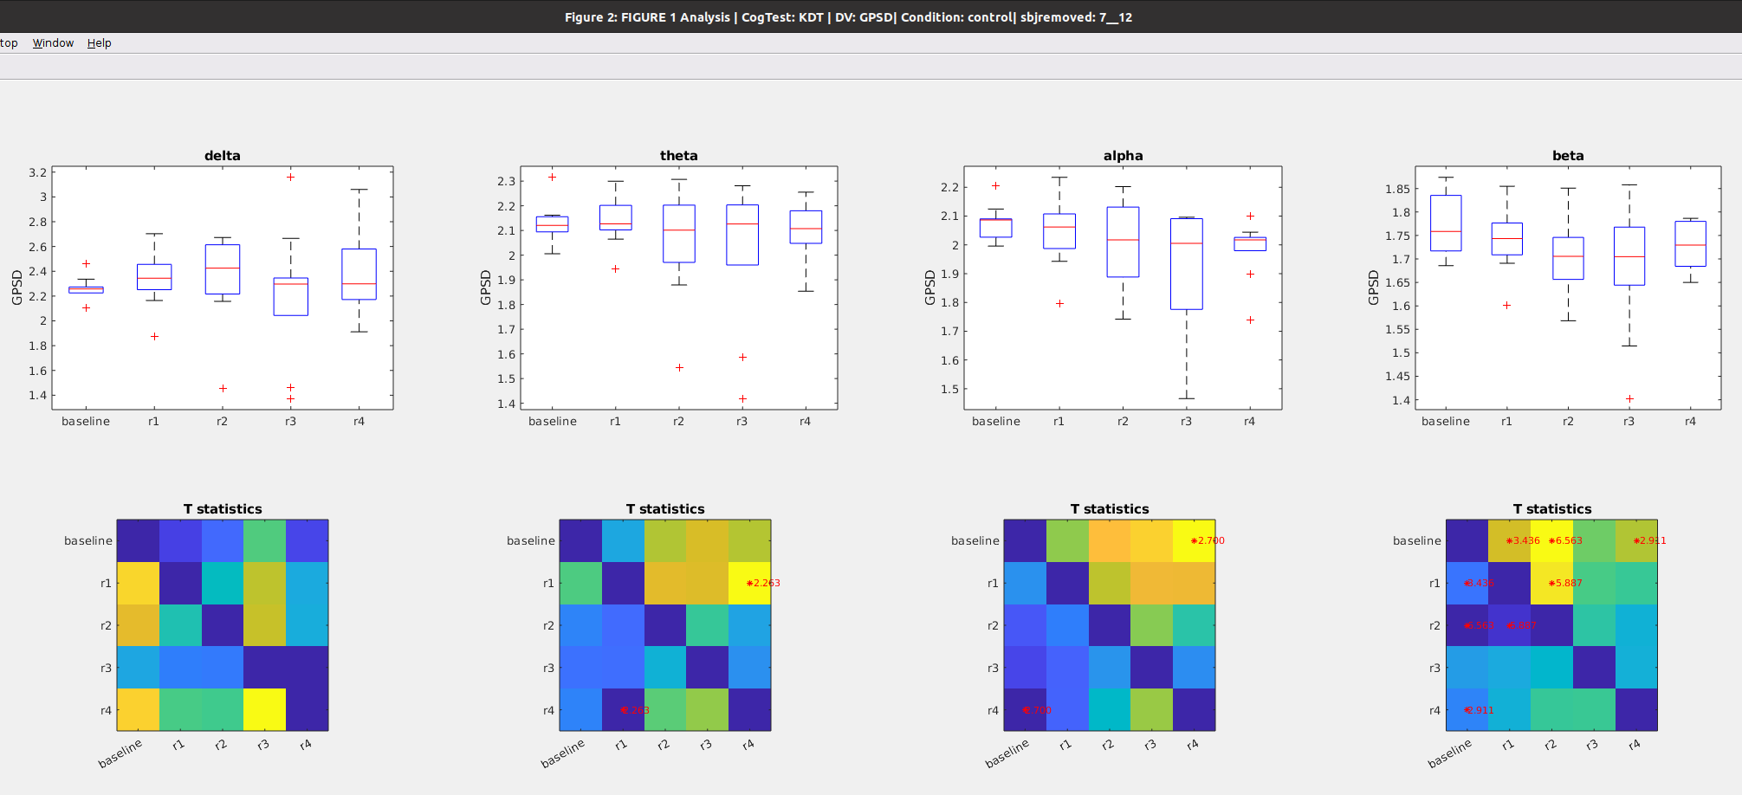

### Figure 3b: Time course of **global** **power** after awakening **WITH** blue light exposure

Notes

* No changes in delta band (1st column) or theta band (2nd column)
* Late onset reduction in alpha band (3rd column)
* Immediate reduction in beta band (4rth column)
* These results roughly similar to the changes seen in the no light condition. Thus blue light doesnt seem to impact the time course of power.

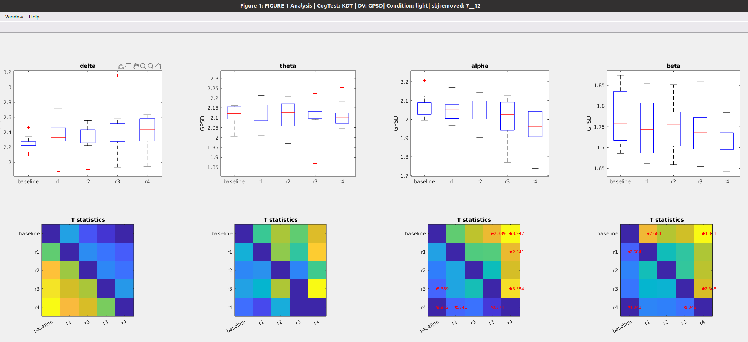

### Figure 3c: **Global power** during preseleep (**baseline**) Vs awakening WITHOUT light exposure (**control_R1**) vs Awakening WITH light exposure (**light_R1**)

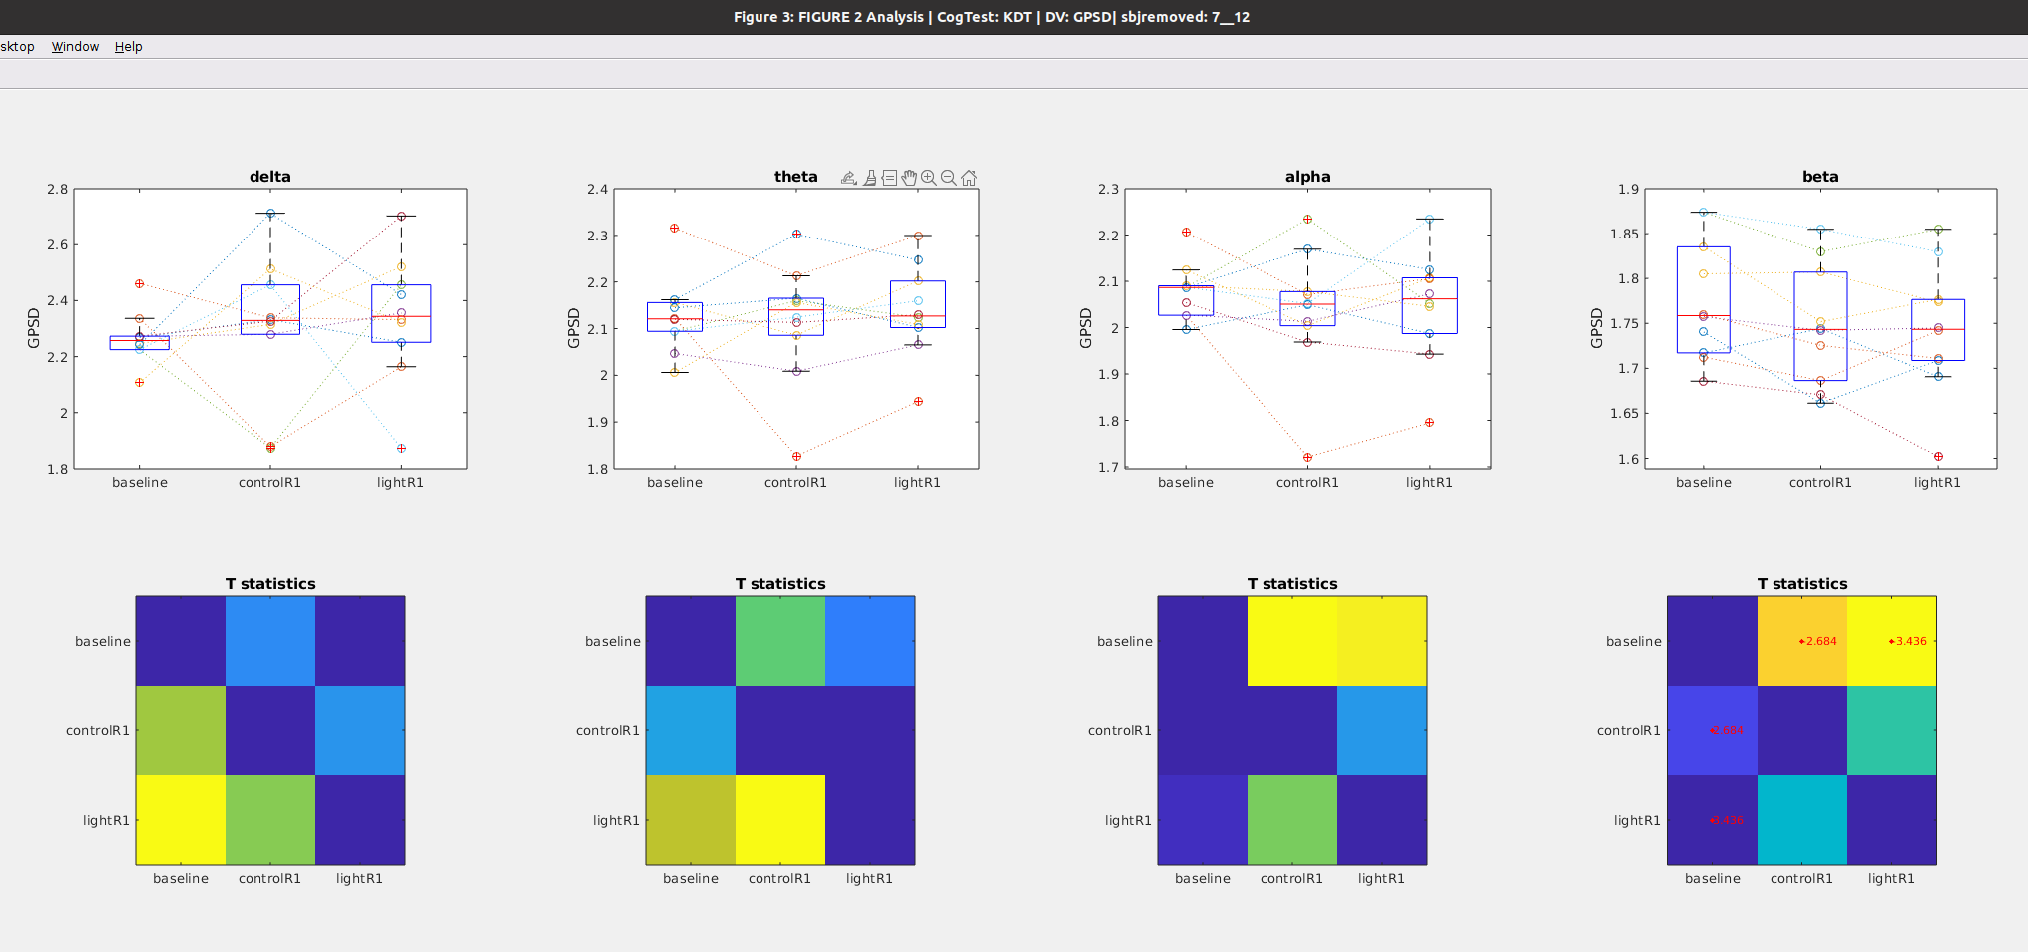

## Path Length during KDT

### Figure 4a: Time course of **Path Length** after awakening **WITHOUT** blue light exposure

Notes

* No changes in path length in any band

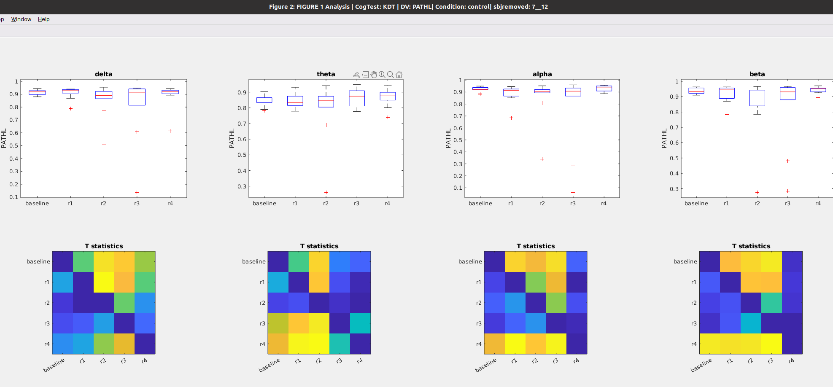

### Figure 4b: Time course of **Path Length** after awakening **WITH blue light exposure**

Notes

* No changes in path length in any band
* These results roughly similar to the changes seen in the no light condition. Thus blue light doesnt seem to impact the time course of power .

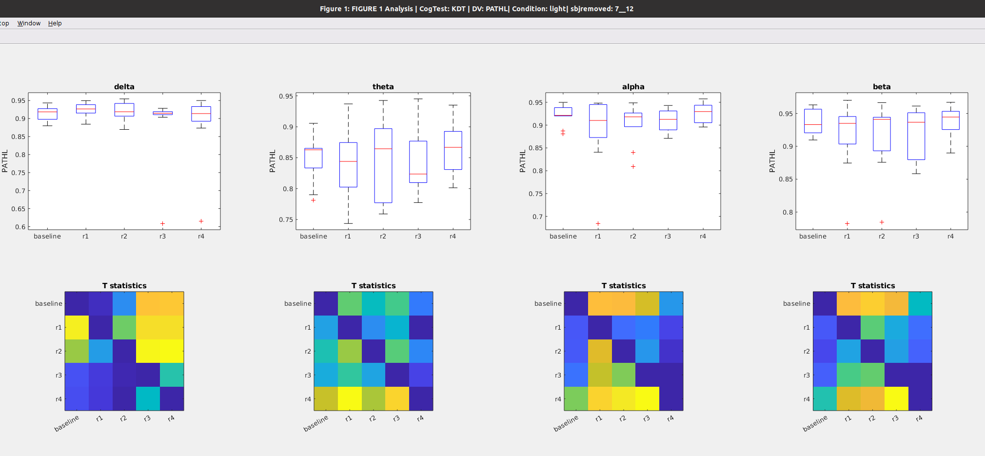

### Figure 4c: **Path Length** during preseleep (**baseline**), Vs awakening WITHOUT light exposure (**control_R1**) vs Awakening WITH light exposure (**light_R1**)

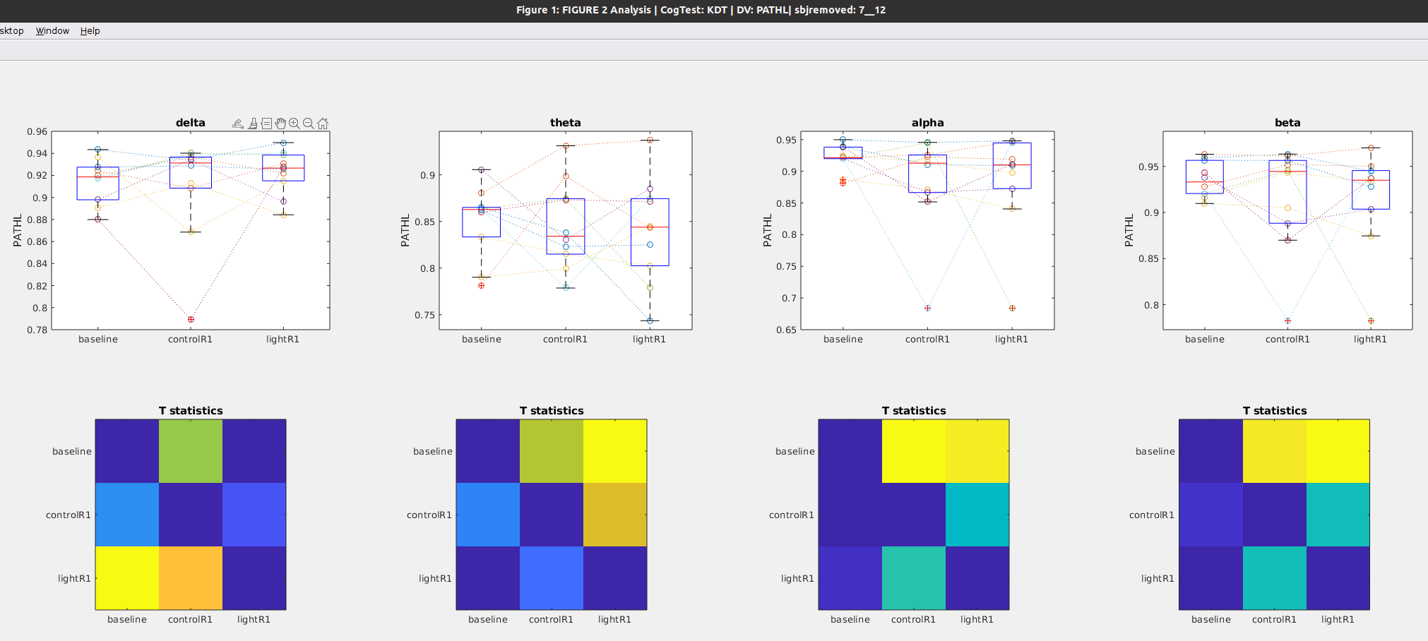

## Clustering during KDT

### Figure 5a: Time course of **Clustering coefficient** after awakening **WITHOUT** blue light exposure

Notes

* No changes in path length in any band

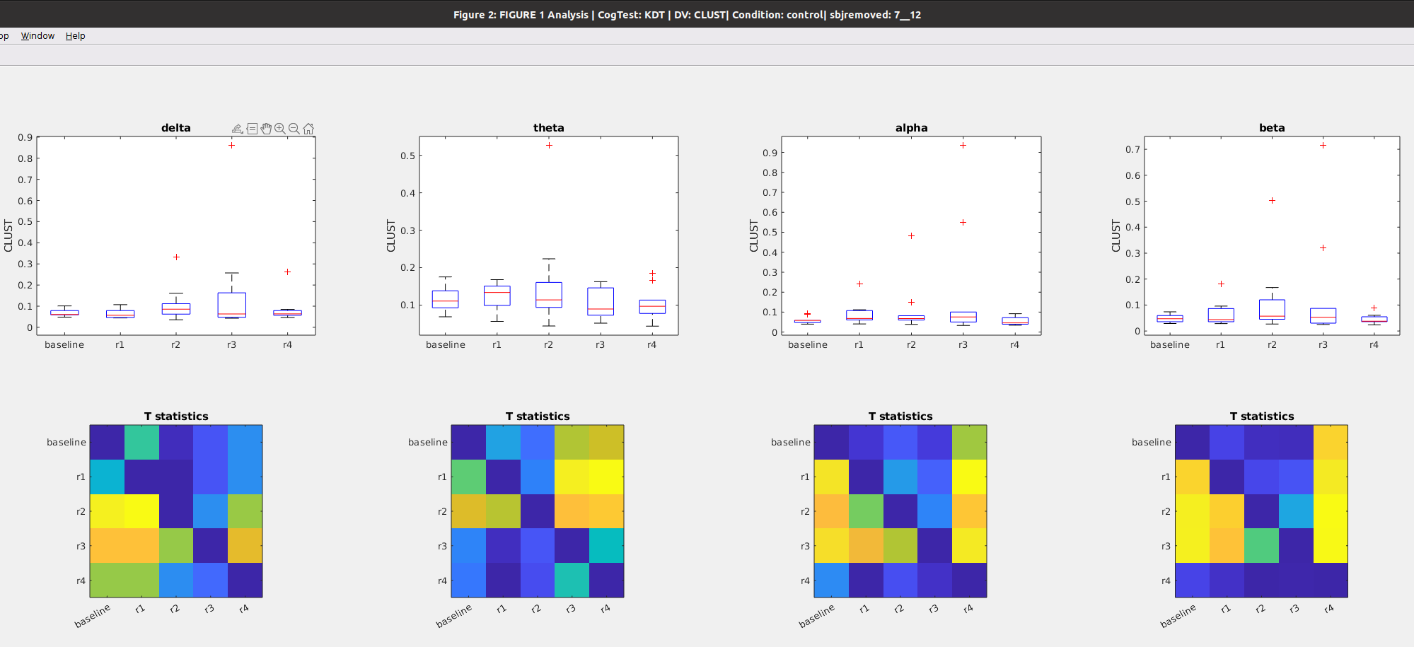

### Figure 5b: Time course of **Clustering coefficient** after awakening **WITH** blue light exposure

Notes

* No changes (from baseline) in path length in any band. (althought there is a reduction in clustering in the 3rd run vs the first run)
* These results roughly similar to the changes seen in the no light condition. Thus blue light doesnt seem to impact the time course of power .

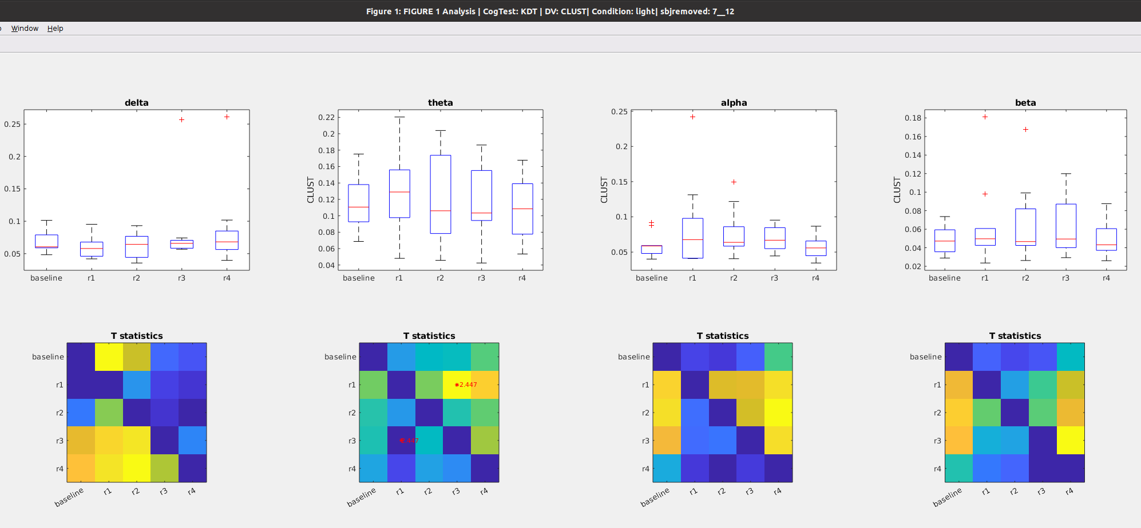

### Figure 5c: **Clustering** during preseleep (**baseline**), Vs awakening WITHOUT light exposure (**control_R1**) vs Awakening WITH light exposure (**light_R1**)

## 

## Betweenness Centrality during KDT

### Figure 6a: Time course of **Betweenness** after awakening **WITHOUT** blue light exposure

Notes

* No changes in delta betweenness (1rst column), alpha betweenness (1rst column),nor beta betweenness (1rst column) from baselin
* Reduction in alpha from baseline at the 4rth time point

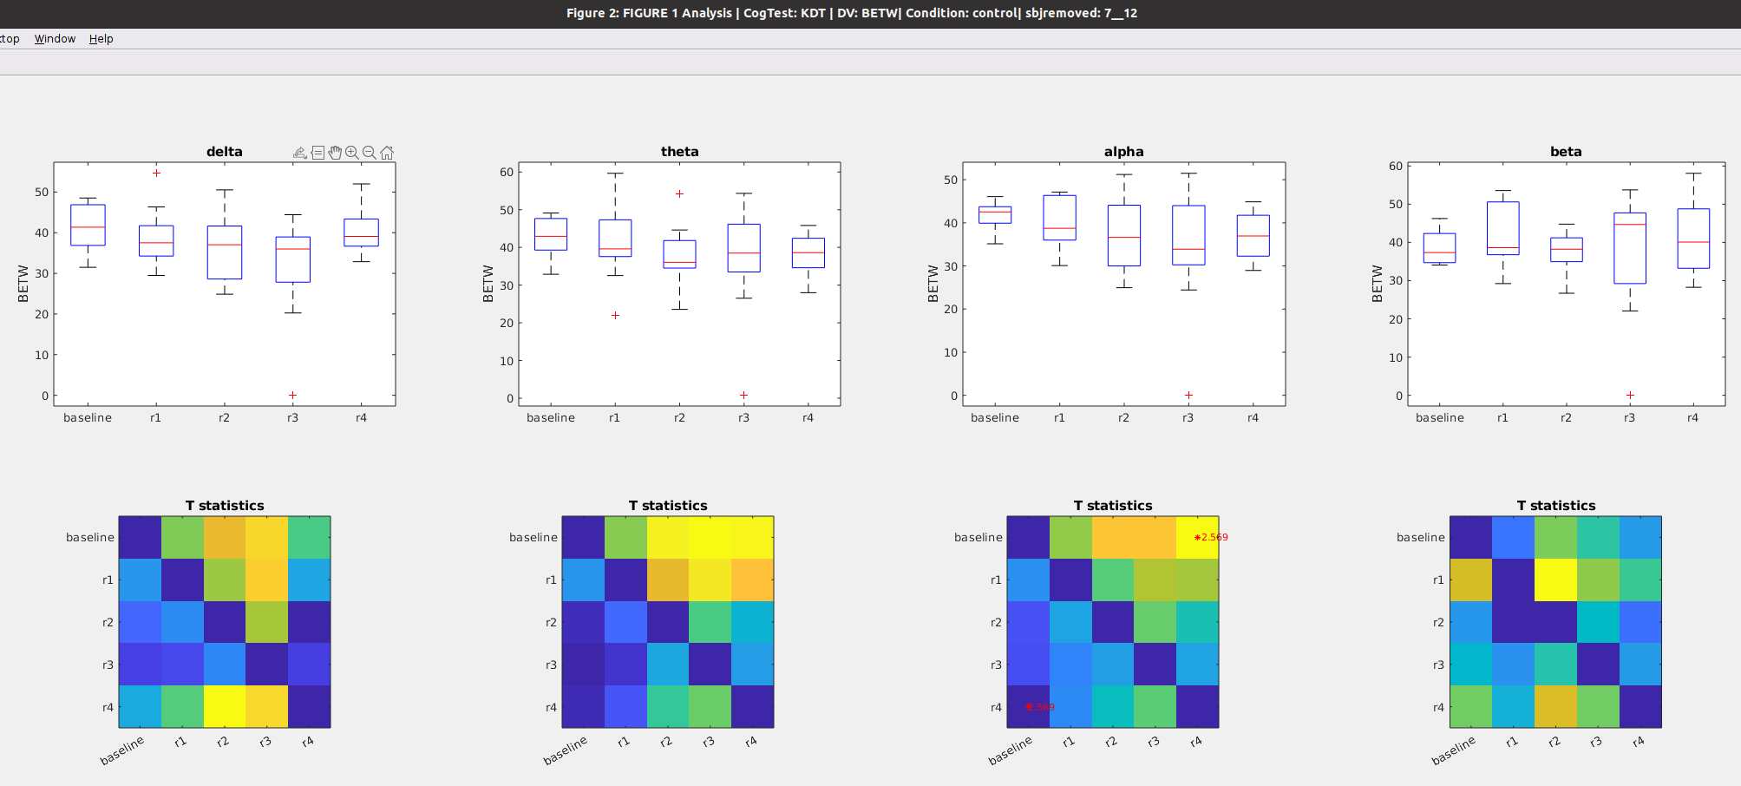

### Figure 6b: Time course of **Betweenness** after awakening **WITH blue light exposure**

Notes

* No changes in delta betweenness (1rst column), alpha betweenness (1rst column),nor beta betweenness (1rst column) from baseline
* Reduction in alpha from baseline at the immediately and again at the 4rth time point

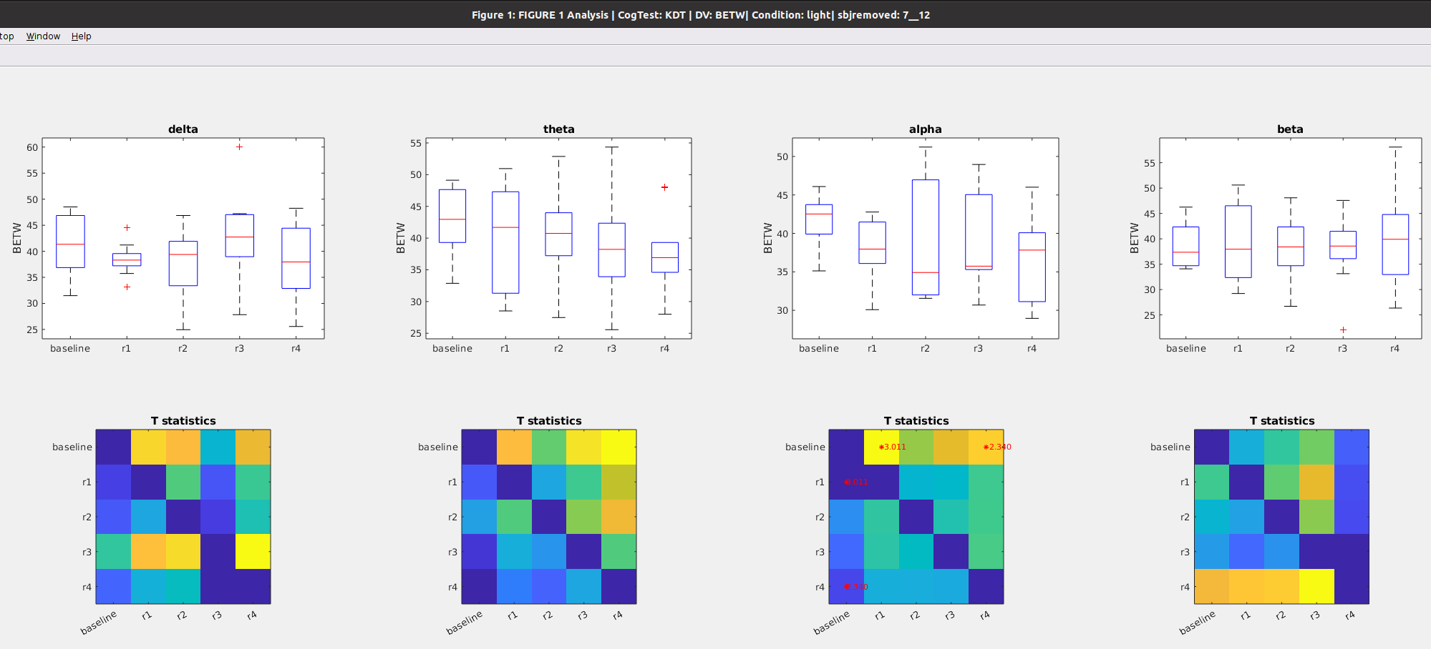

### Figure 6c: **Betweennes** during preseleep (**baseline**) Vs awakening WITHOUT light exposure (**control_R1**) vs Awakening WITH light exposure (**light_R1**)

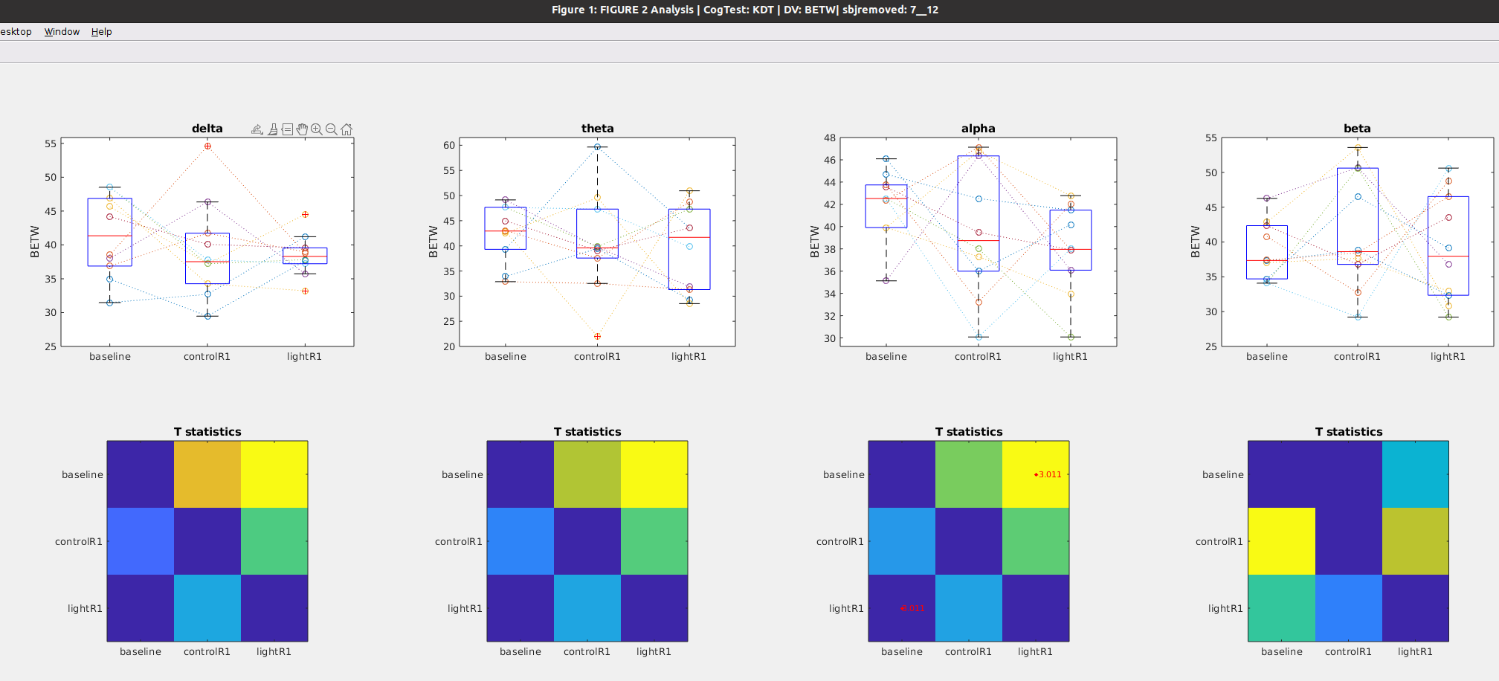

## WPLI during KDT

### Figure 7a: Time course of **WPLI** after awakening **WITHOUT** blue light exposure

Notes

* No changes in delta wpli after awakening (see 1rst column)
* Immediate Increase in theta wpli after awakening but quickly recovers by the second run (see 2nd column)
* Delayed increase in alpha wpli that recovers by the fourth run (see 3rd column)
* Delayed increase in beta wpli (on the second run) that does not recover (see 4rth column)

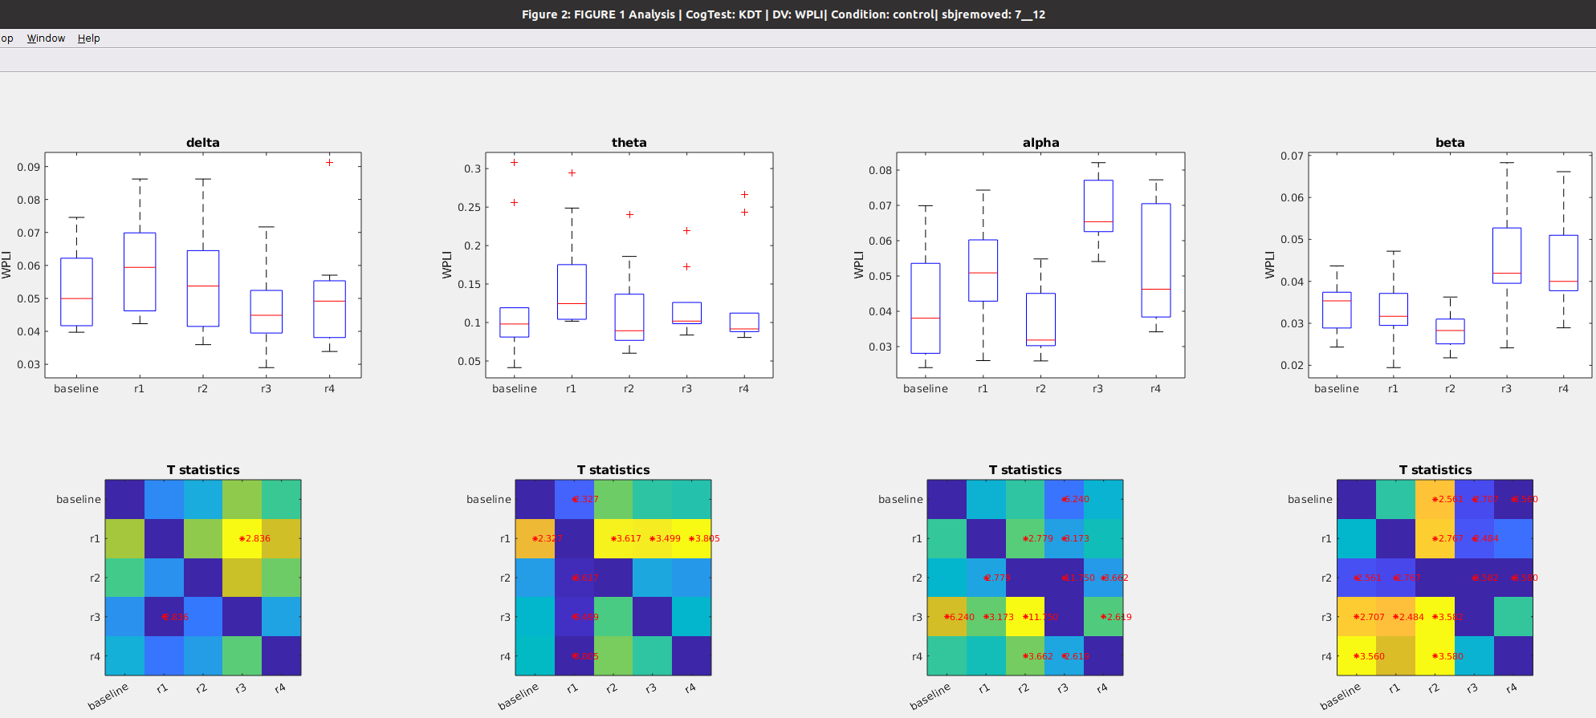

### Figure 7b: Time course of **WPLI** after awakening **WITH** blue light exposure

Notes

* Alpha band shows a delayed reduction from baseline, at the 4rth timepoint
  + This is different from the no-light condition, where there are no changes in alpha band
* Theta wpli increases at the second time point, but returns back to baseline levels by the third time point
* Alpha band increases from baseline at the second time point and does not recover,
  + In contrast, in the no light condition, alpha wpli increases at a later time and recovers immediately

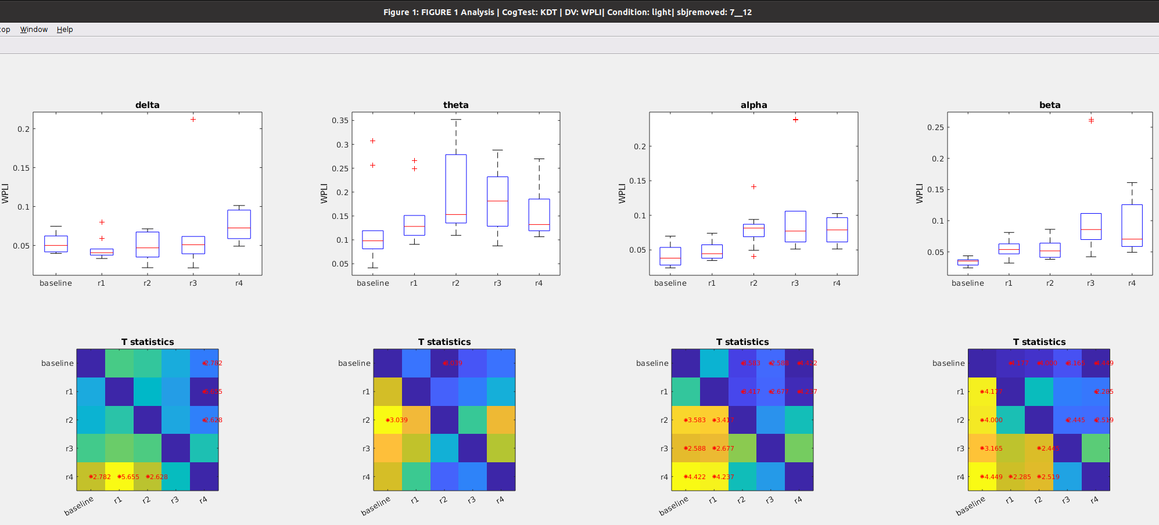

### Figure 7c: **WPLI** during preseleep (**baseline**) Vs awakening WITHOUT light exposure (**control_R1**) vs Awakening WITH light exposure (**light_R1**)

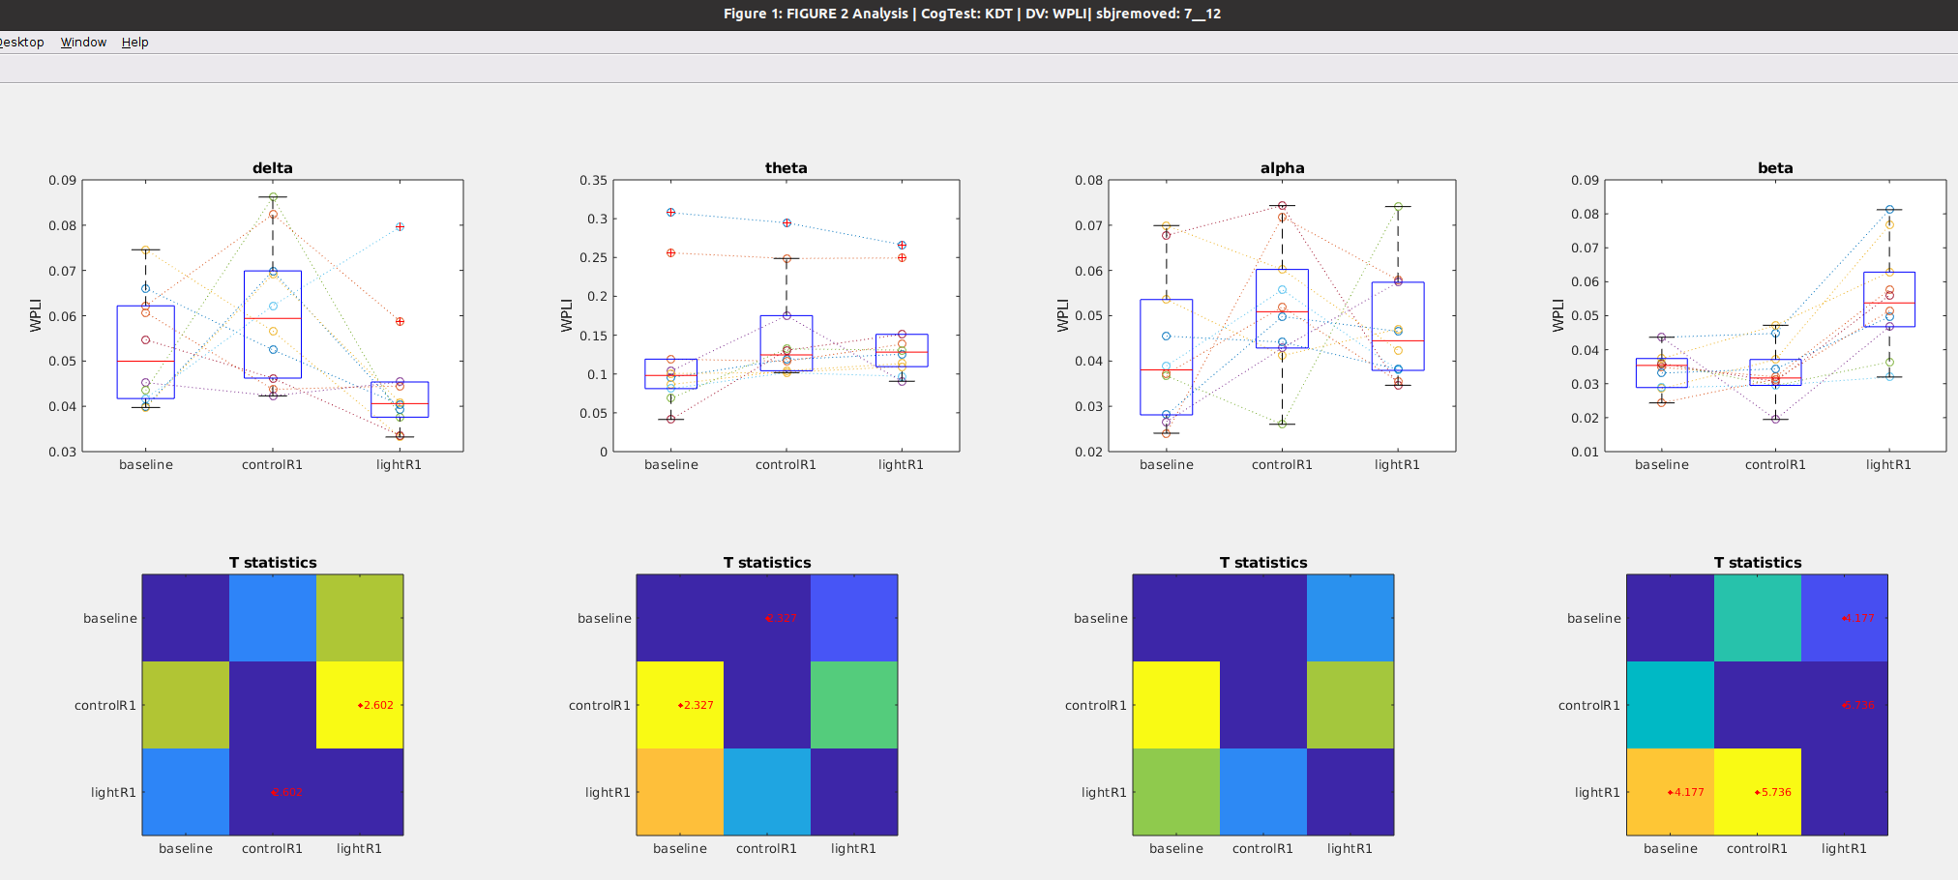

# Math Task

Notes on Data Set

* Removed subjects 5, 8 and 10 for missing data, so n = 9

## Global Power during Math

### Figure 8a: Time course of **global** after awakening **WITHOUT** blue light exposure

Notes

* Theta, alpha and beta global power all decrease by the second time point, but return to baseline levels by the 4rth time point
* No changes in the delta band (1rst column)

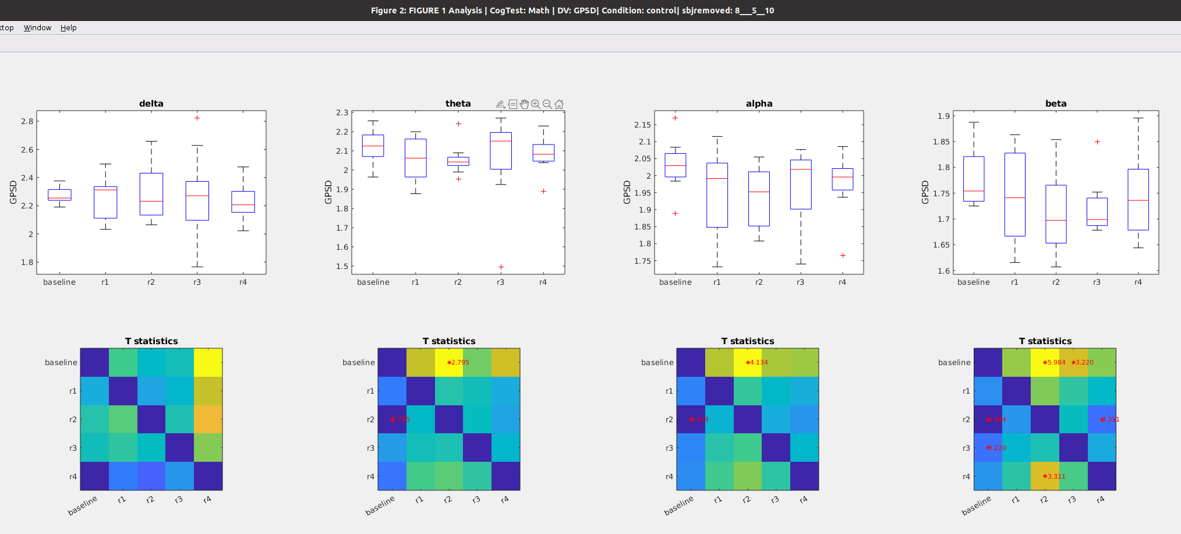

### Figure 8b: Time course of **global** **power** after awakening **WITH** blue light exposure

Notes

* No changes in delta band with blue light exposure, same as when no-exposure
* No changes in theta band with blue light exposure, different from the reduction observed with no-exposure
* In the alpha band, when exposed to light a reduction occurs at a later time point and does not revert back to baseline, compared to the no light condition,
* In the beta band, reduction is observed immediately after awakening

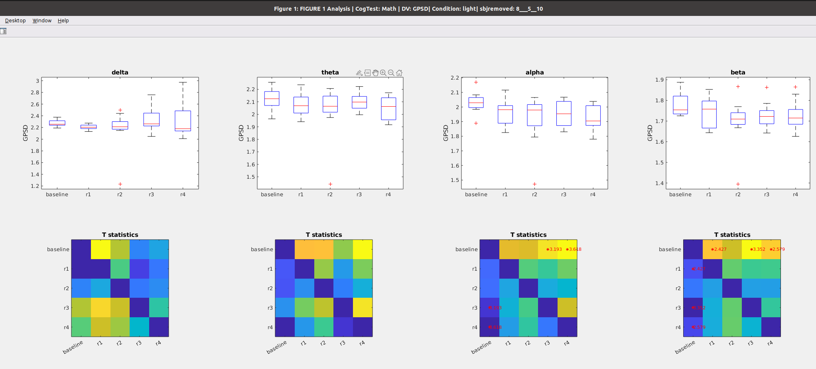

### Figure 8C: **Global power** during preseleep (**baseline**) Vs awakening WITHOUT light exposure (**control_R1**) vs Awakening WITH light exposure (**light_R1**)

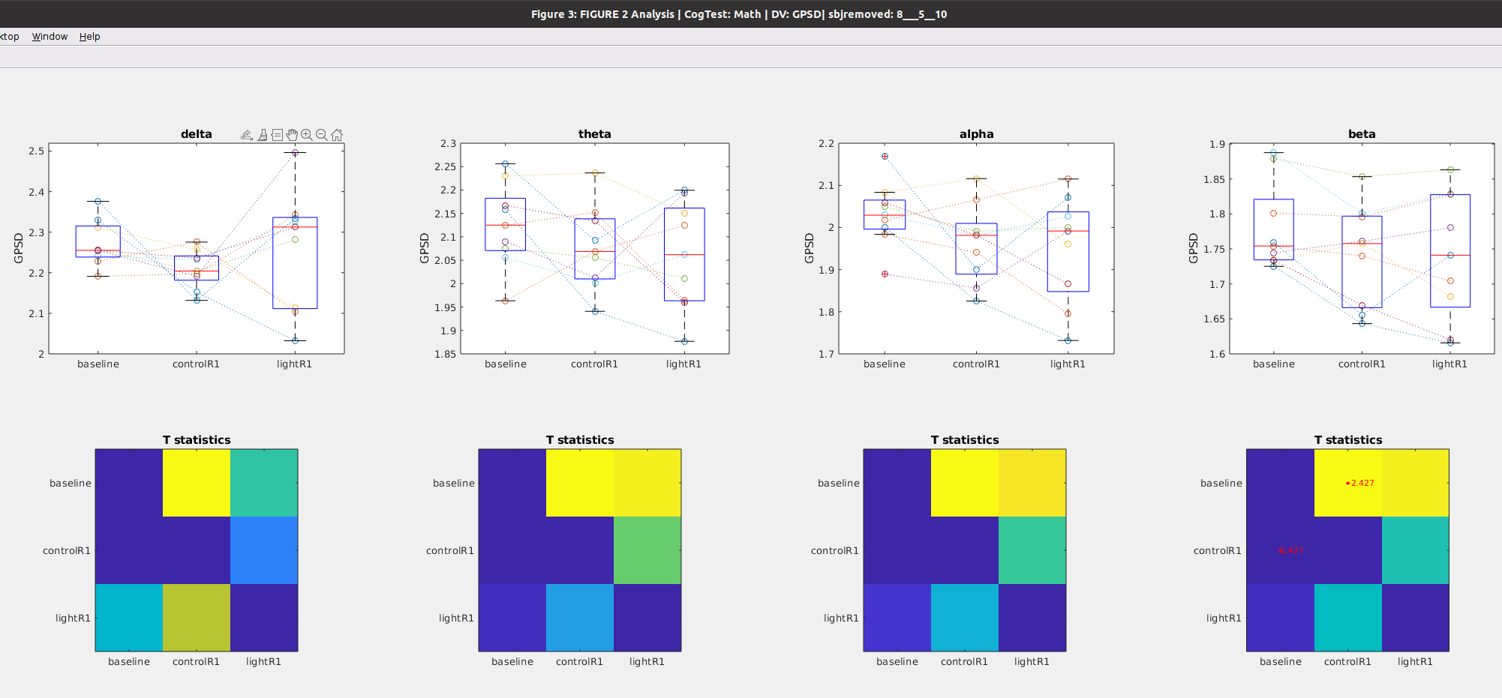

## 

## Path Length during Math Task

### Figure 9a: Time course of **Path Length** after awakening **WITHOUT blue light exposure**

Notes

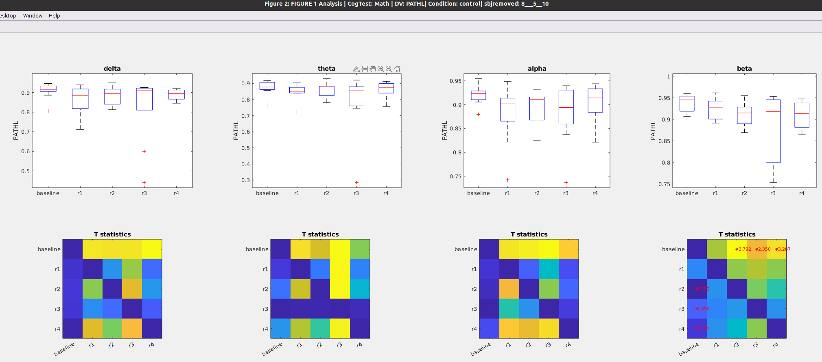

### Figure 9b: Time course of **Path Length** after awakening **WITH blue light exposure**

Notes

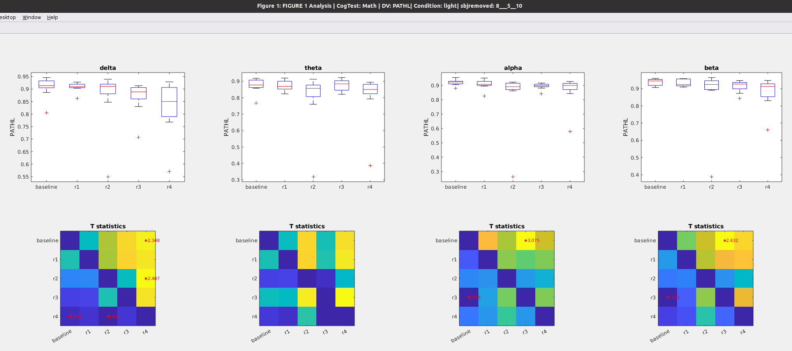

### Figure 9C: **Path Length** during preseleep (**baseline**) Vs awakening WITHOUT light exposure (**control_R1**) vs Awakening WITH light exposure (**light_R1**)

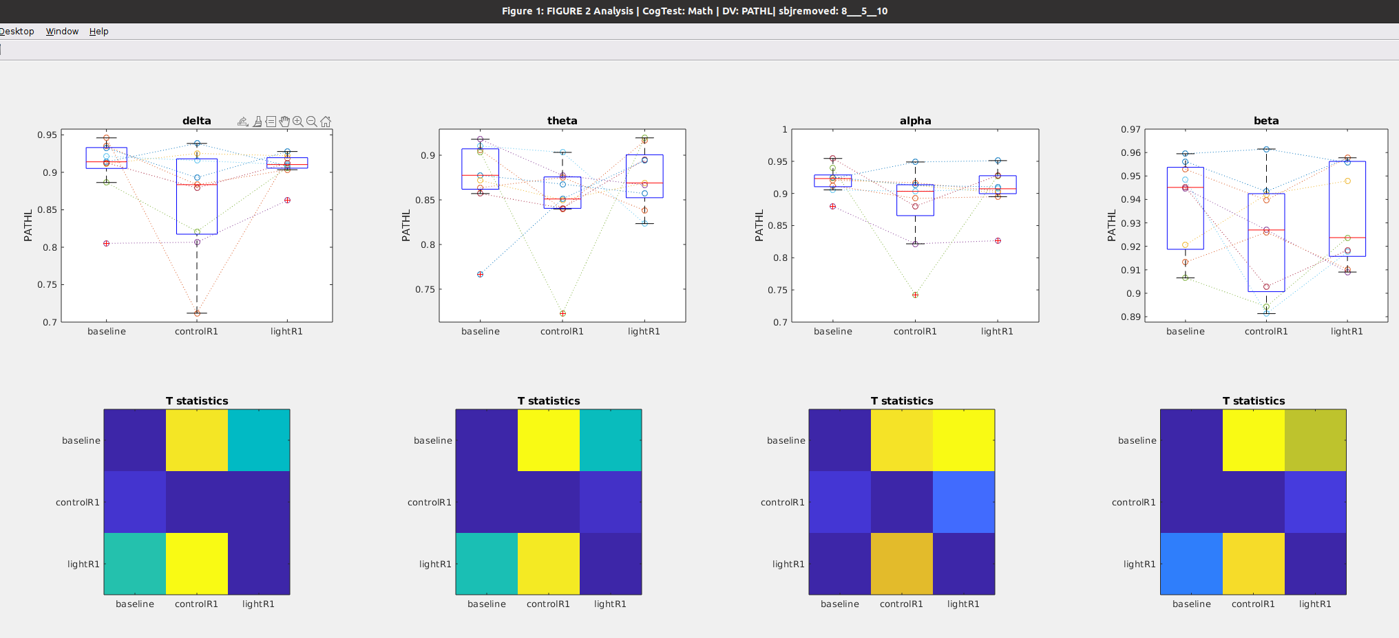

## Clustering during Math

### Figure 10a: Time course of **Clustering coefficient** after awakening **WITHOUT blue light exposure**

Notes

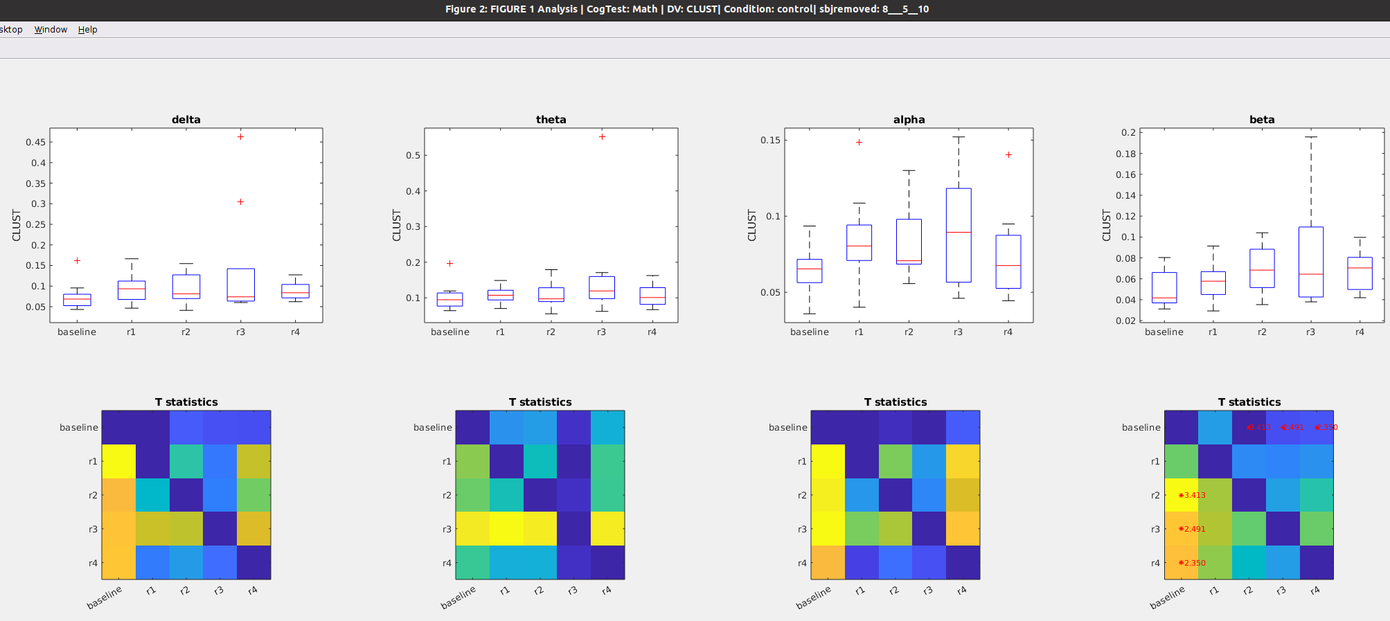

### Figure 10b: Time course of **Clustering coefficient** after awakening **WITH blue light exposure**

Notes

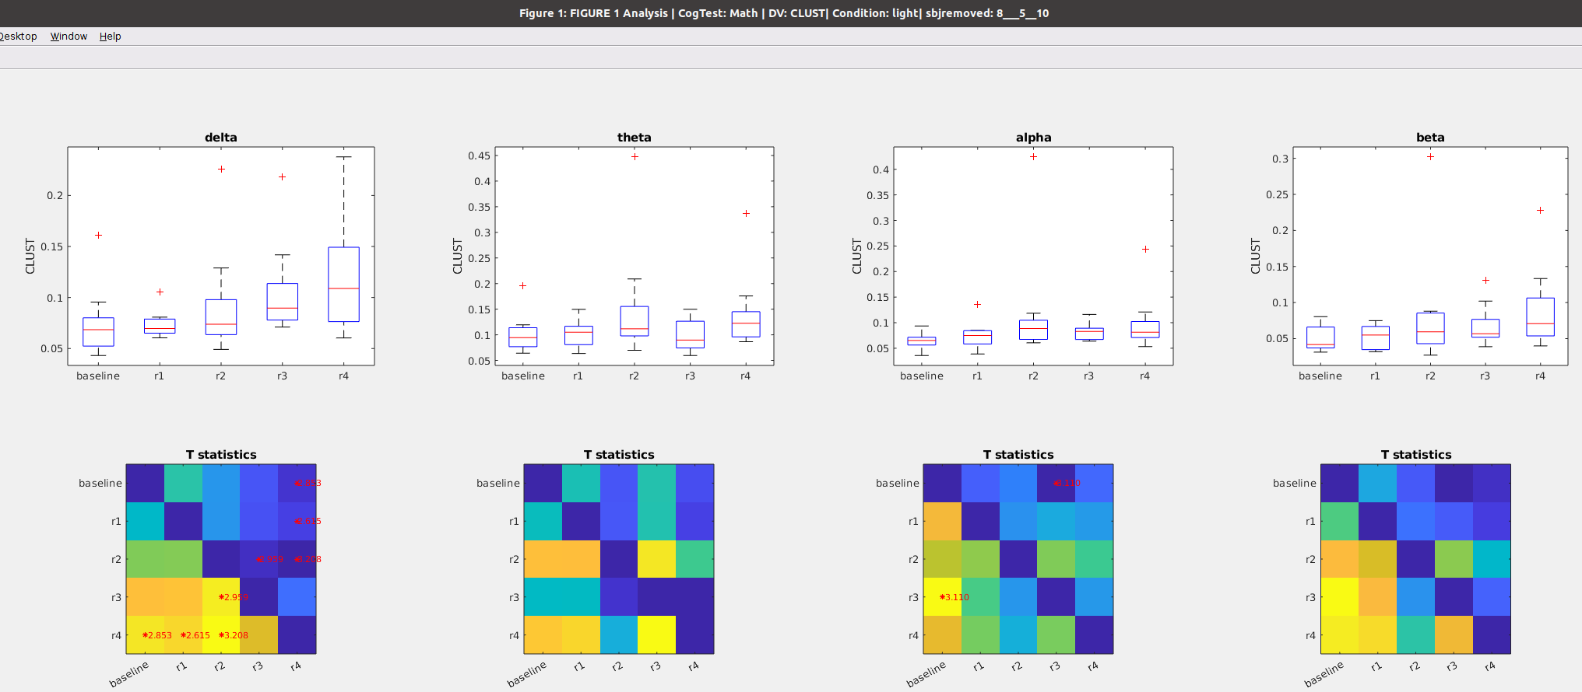

### Figure 10C: **Clustering** during preseleep (**baseline**) Vs awakening WITHOUT light exposure (**control_R1**) vs Awakening WITH light exposure (**light_R1**)

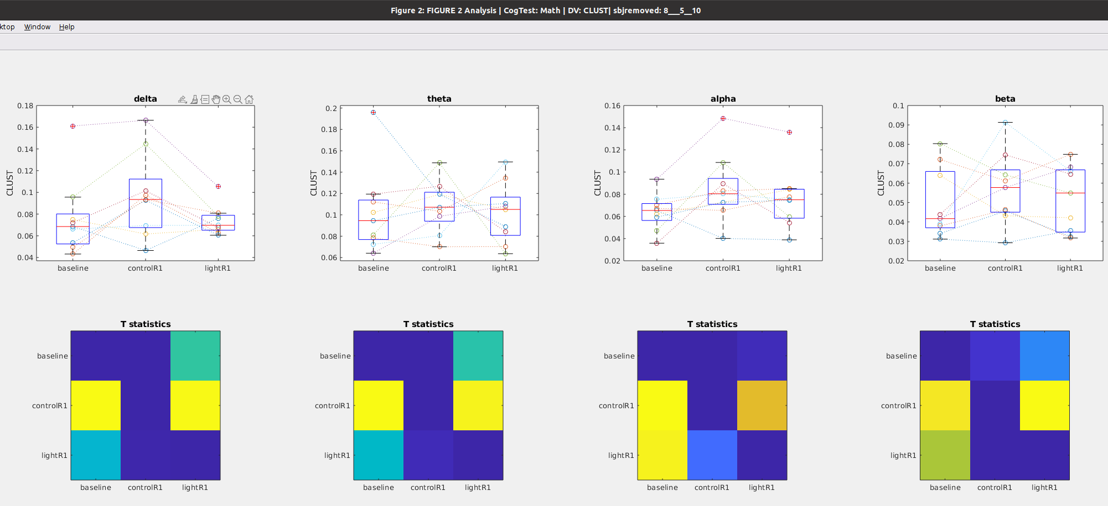

## Betweenness Centrality during Math

### Figure 11a: Time course of **Betweenness** after awakening **WITHOUT** blue light exposure

Notes

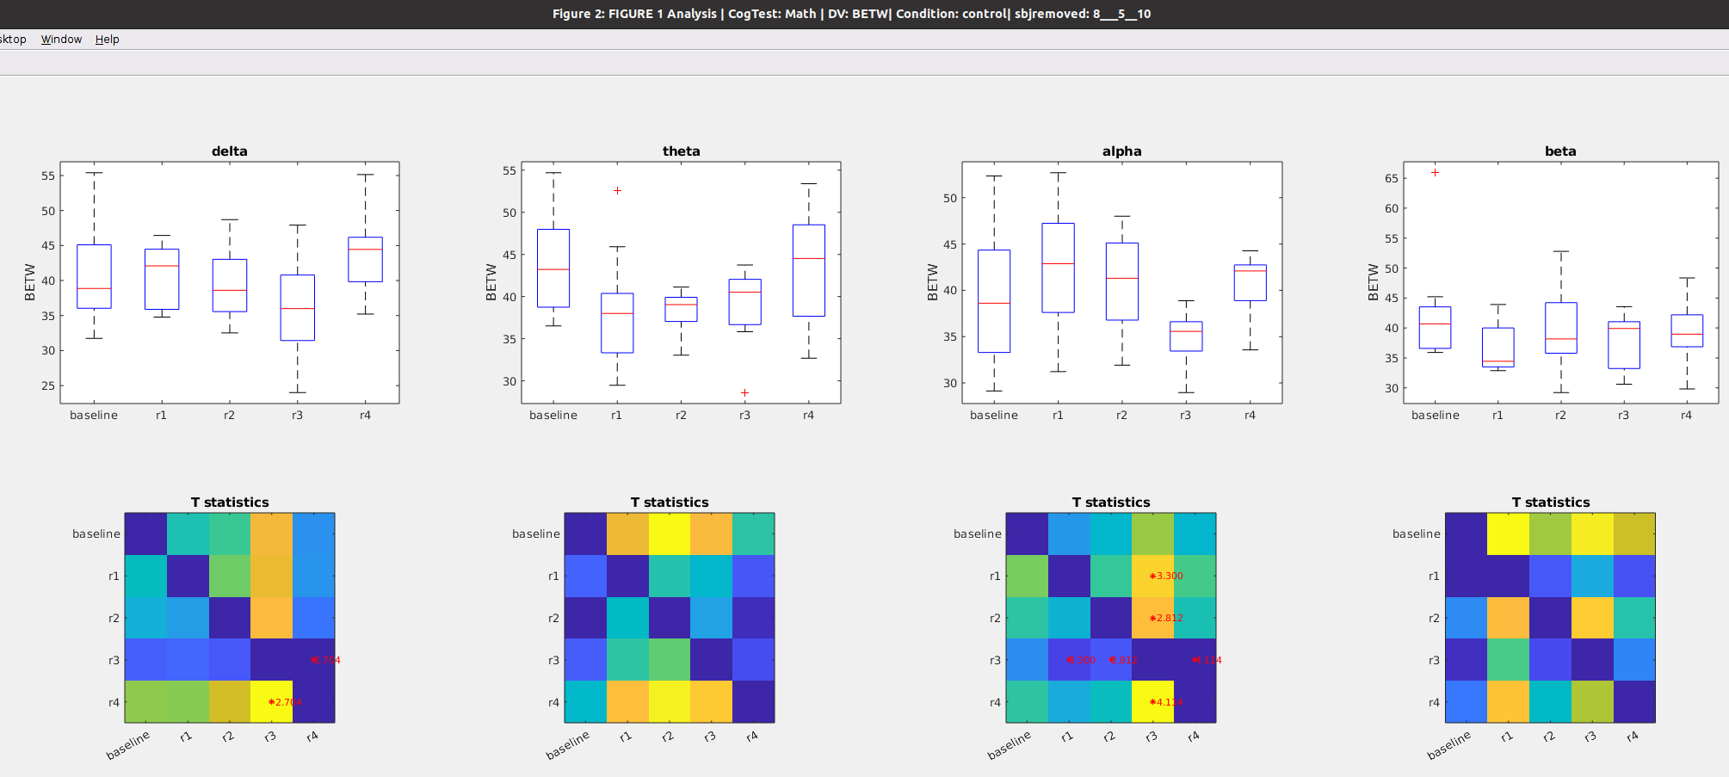

### Figure 11b: Time course of **Betweenness** after awakening **WITH blue light exposure**

Notes

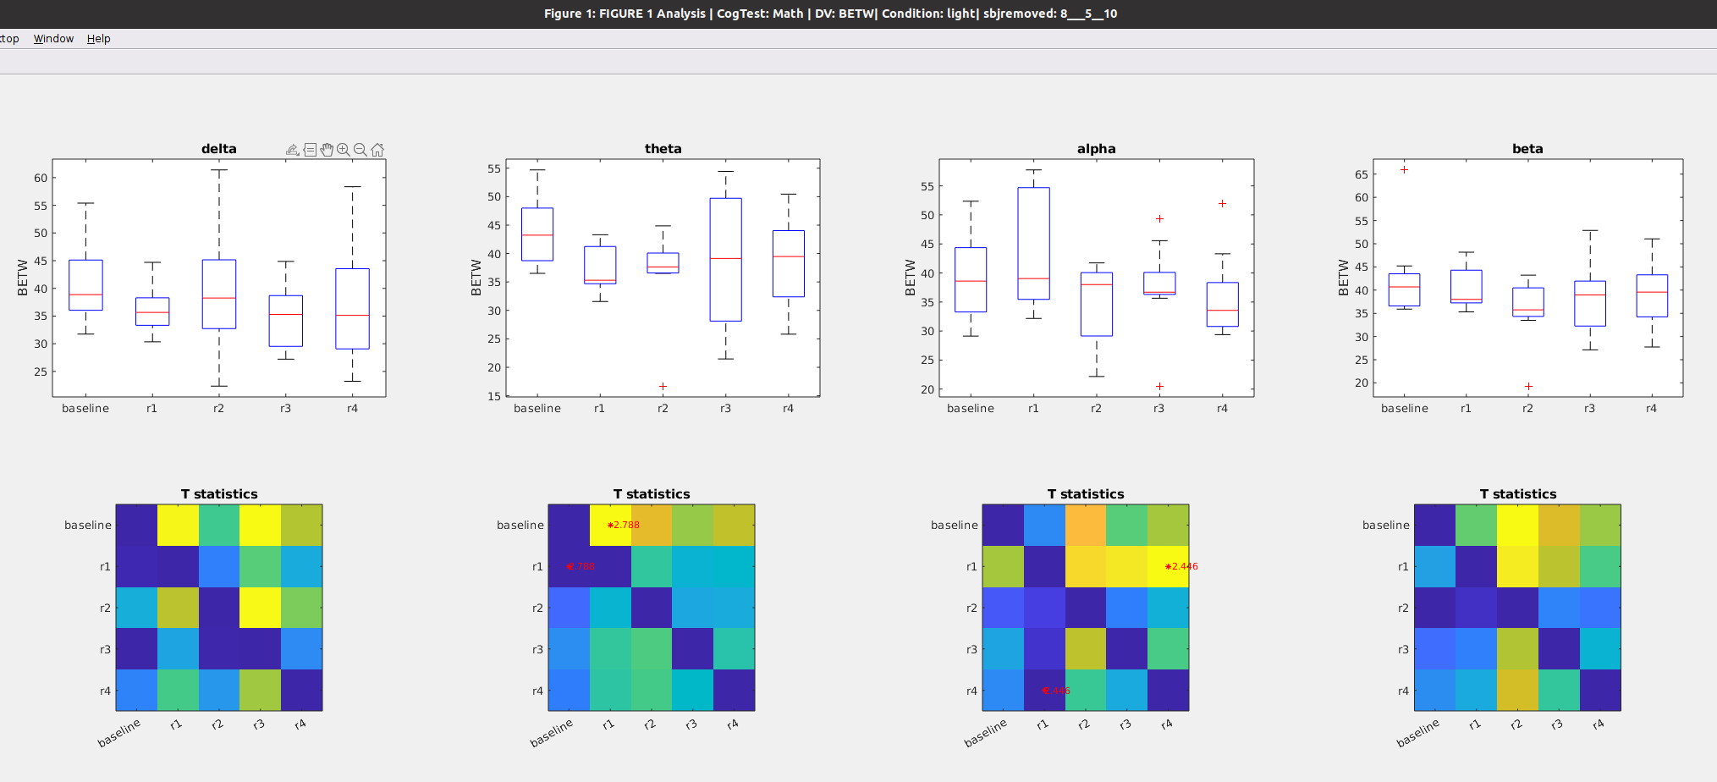

￼￼￼

### Figure 11c: **Betweennes** during preseleep (**baseline**) Vs awakening WITHOUT light exposure (**control_R1**) vs Awakening WITH light exposure (**light_R1**)

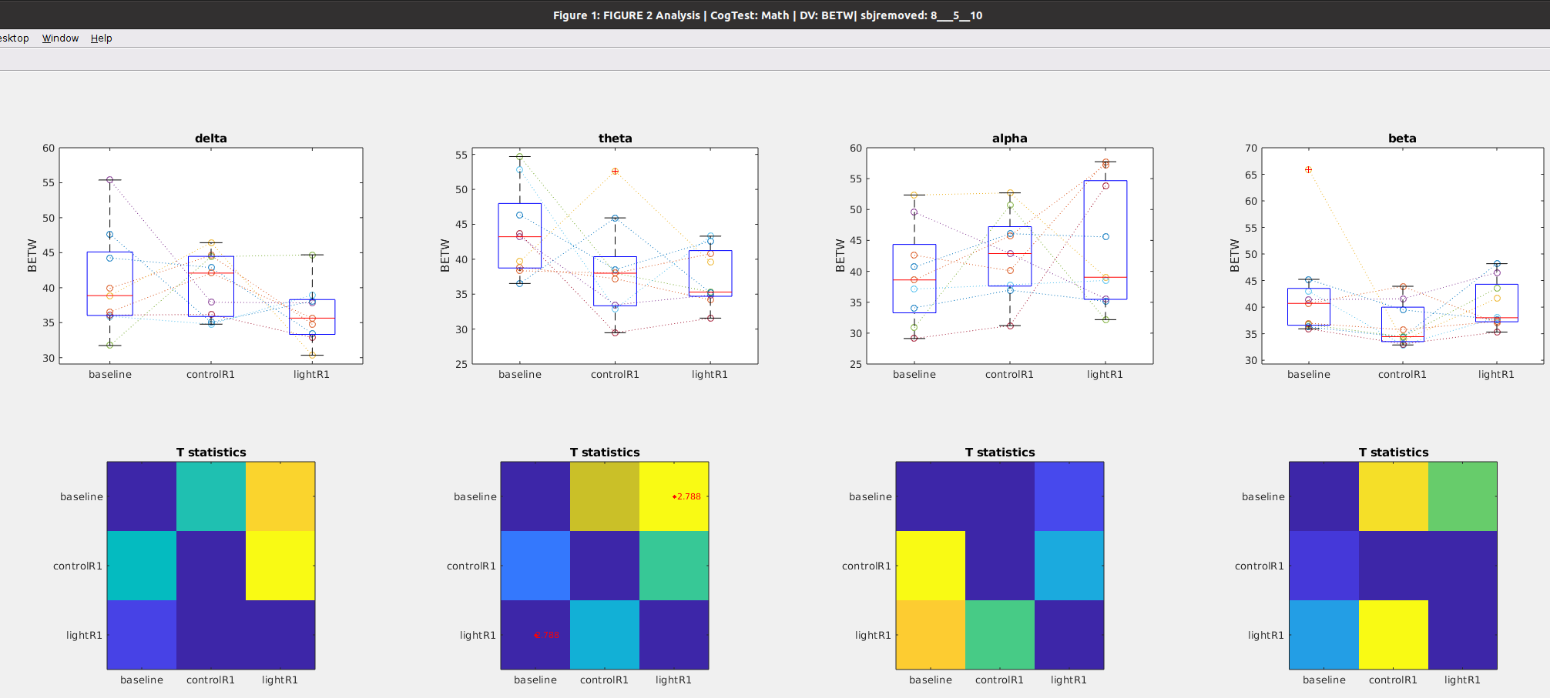

## WPLI during Math

### Figure 12a: Time course of **WPLI** after awakening **WITHOUT** blue light exposure

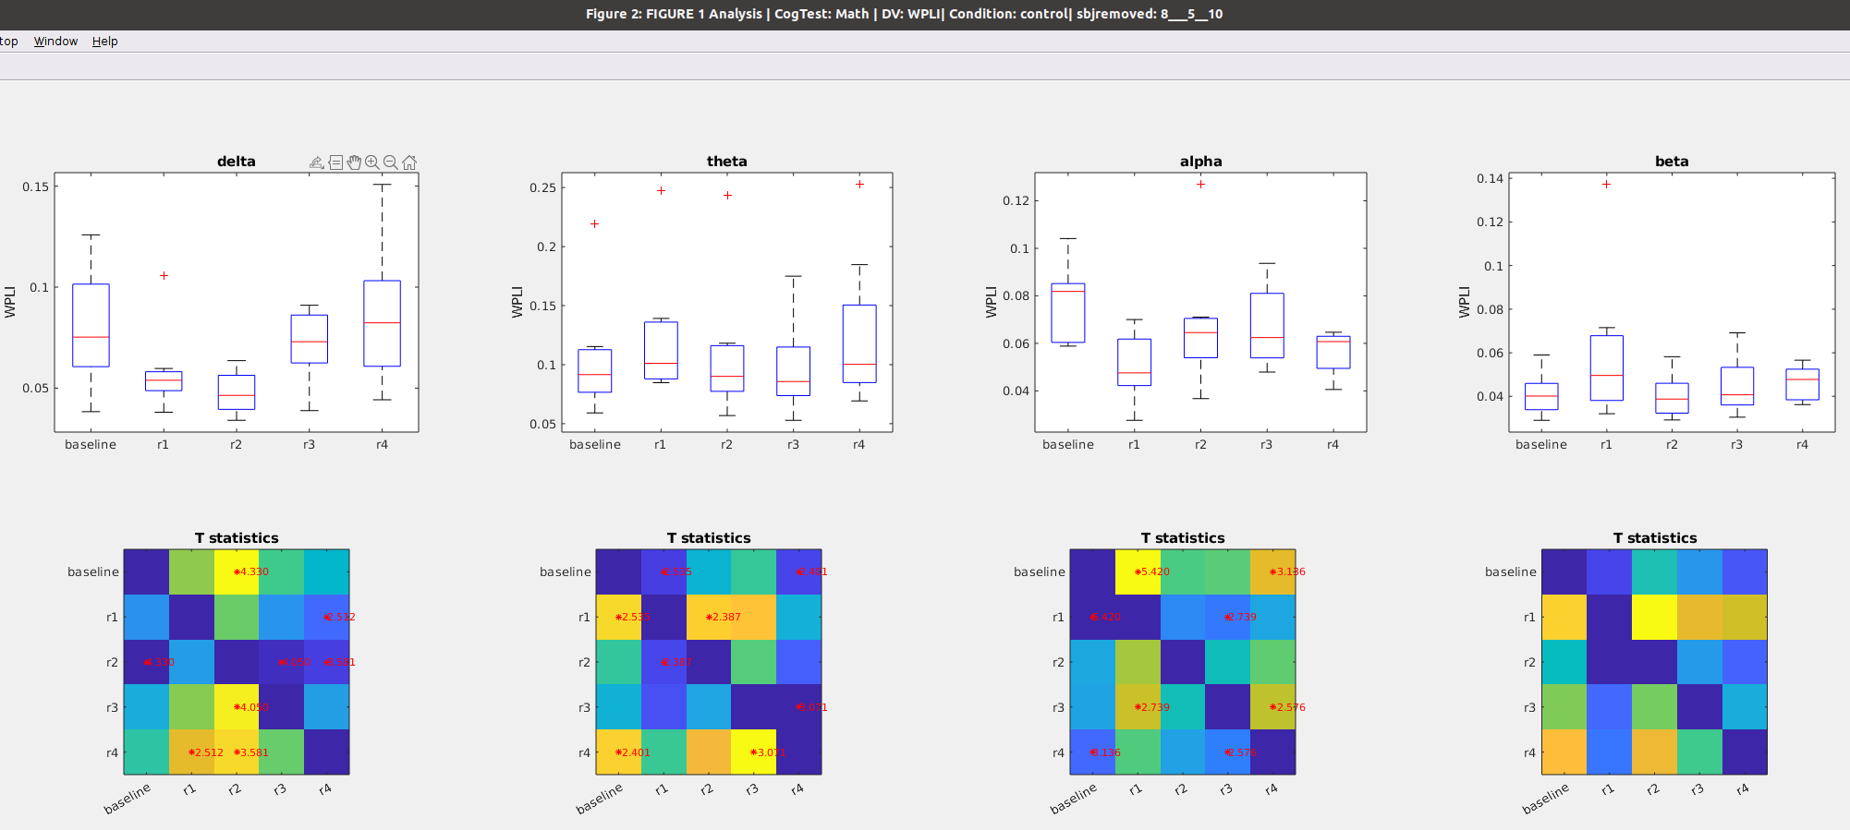

### Figure 12b: Time course of **WPLI** after awakening **WITH** blue light exposure

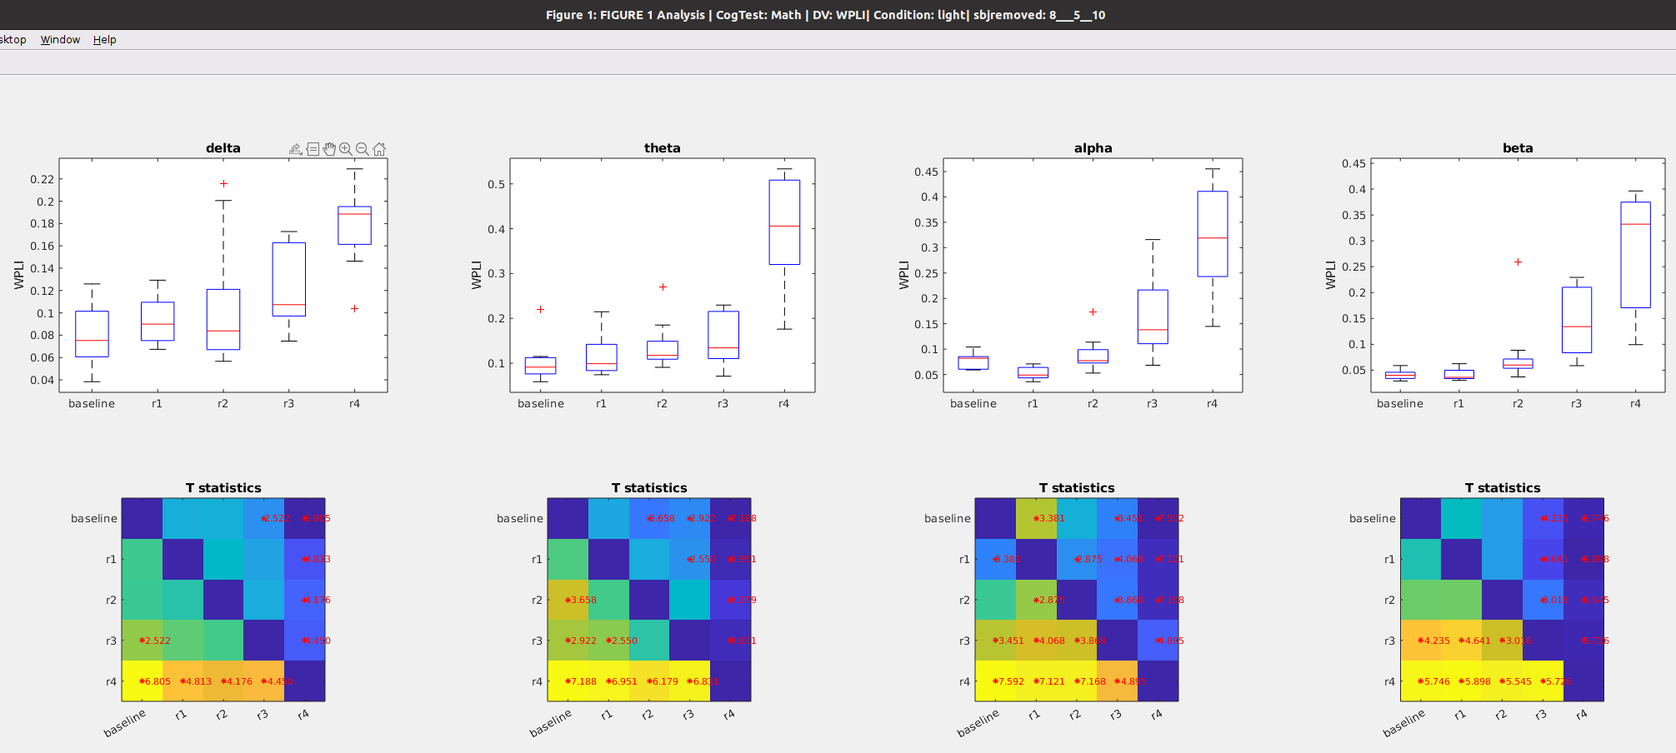

### Figure 12C: **WPLI** during preseleep (**baseline**) Vs awakening WITHOUT light exposure (**control_R1**) vs Awakening WITH light exposure (**light_R1**)

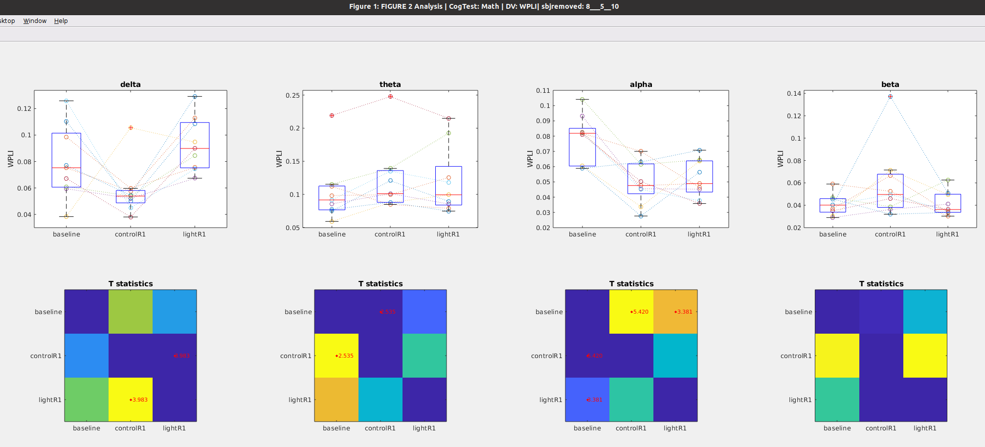

# GoNogo Task

Notes on Data Set

* Removed subjects 5, 7 and 8 and 10 for missing data, so n = 9

## Global Power during GoNogo Task

### Figure 13a: Time course of **global** **Power** after awakening **WITHOUT** blue light exposure

Notes

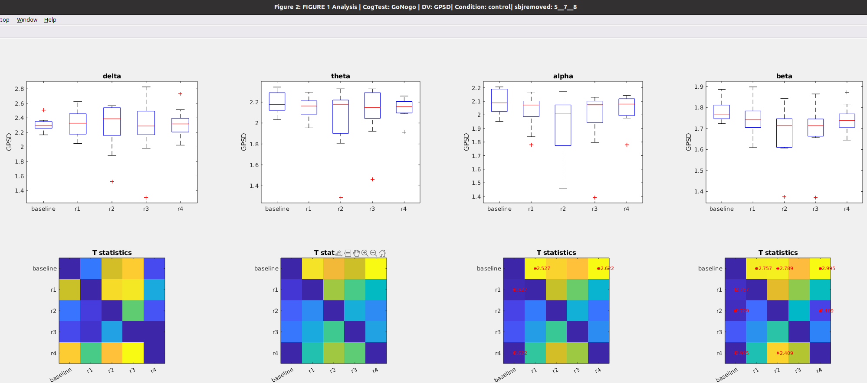

### Figure 13b: Time course of **global** **power** after awakening **WITH** blue light exposure

Notes

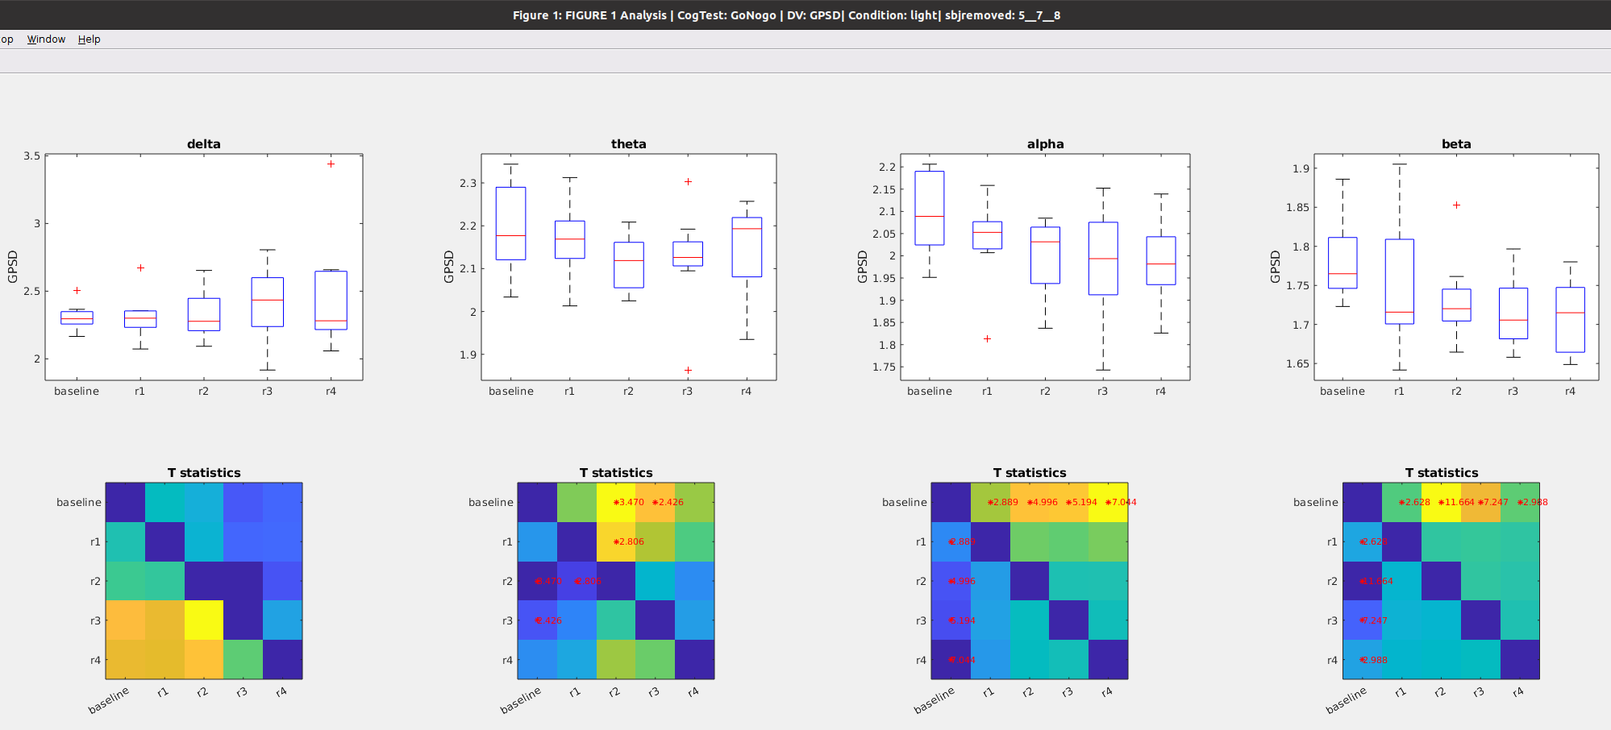

### Figure 13C: **Global power** during preseleep (**baseline**) Vs awakening WITHOUT light exposure (**control_R1**) vs Awakening WITH light exposure (**light_R1**)

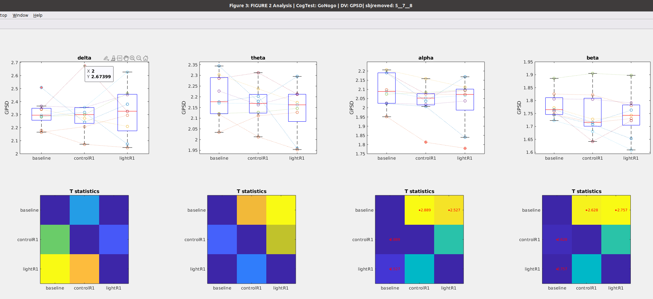

## Path Length during GoNogo Task Task

### Figure 14a: Time course of **Path Length** after awakening **WITHOUT blue light exposure**

Notes

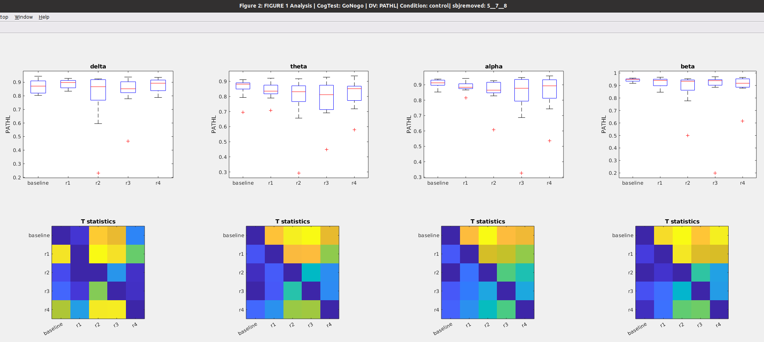

### Figure 14b: Time course of **Path Length** after awakening **WITH blue light exposure**

Notes

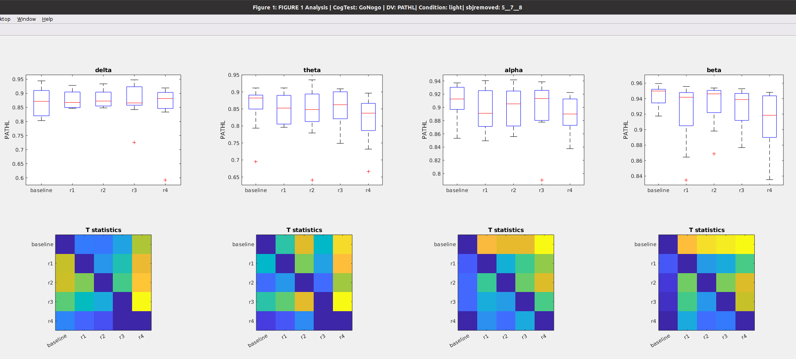

### Figure 14c: **Path Length** during preseleep (**baseline**), Vs awakening WITHOUT light exposure (**control_R1**) vs Awakening WITH light exposure (**light_R1**)

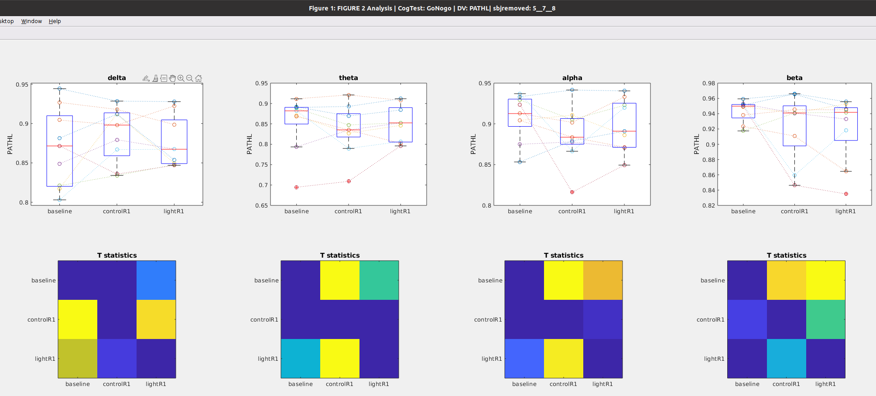

## Clustering during GoNogo Task

### Figure 15a: Time course of **Clustering coefficient** after awakening **WITHOUT blue light exposure**

Notes

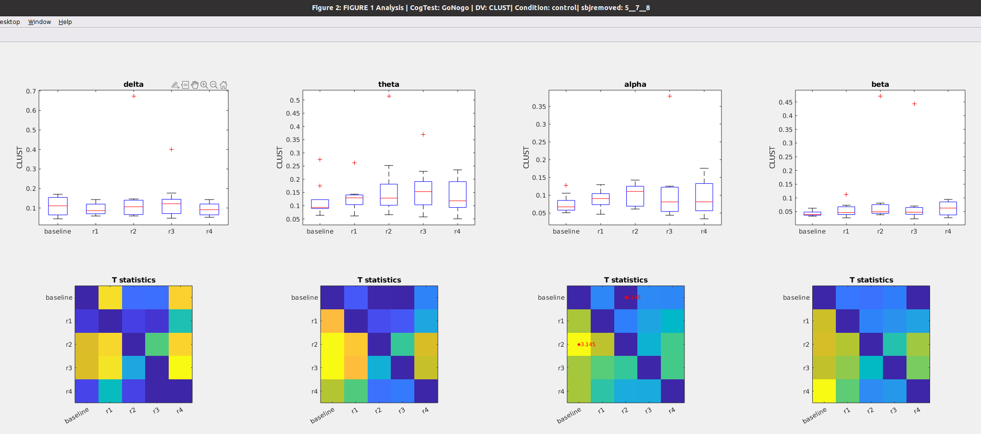

### Figure 15b: Time course of **Clustering coefficient** after awakening **WITH blue light exposure**

Notes

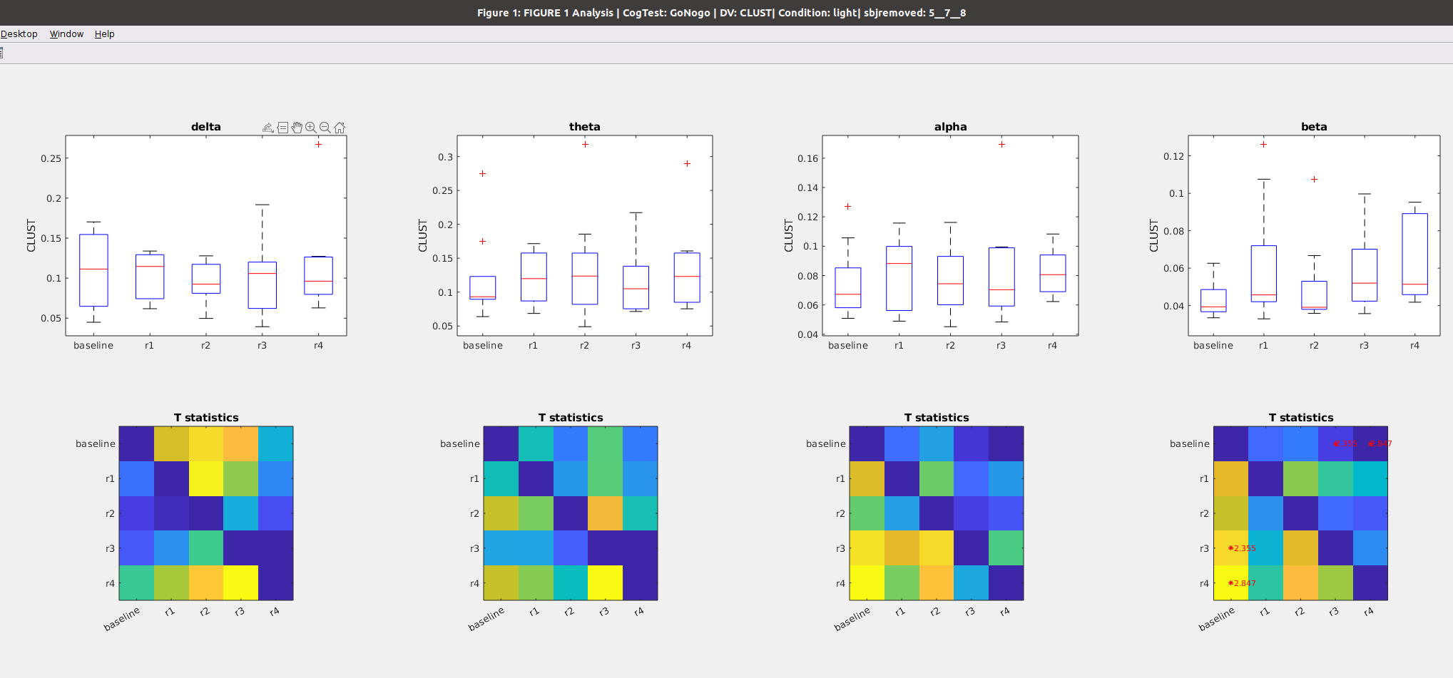

### Figure 15C: **Clustering** during preseleep (**baseline**), Vs awakening WITHOUT light exposure (**control_R1**) vs Awakening WITH light exposure (**light_R1**)

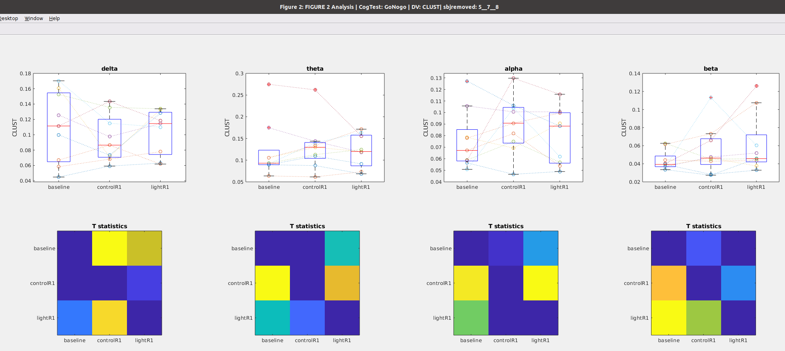

## Betweenness Centrality during GoNogo Task

### Figure 16a: Time course of **Betweenness** after awakening **WITHOUT** blue light exposure

Notes

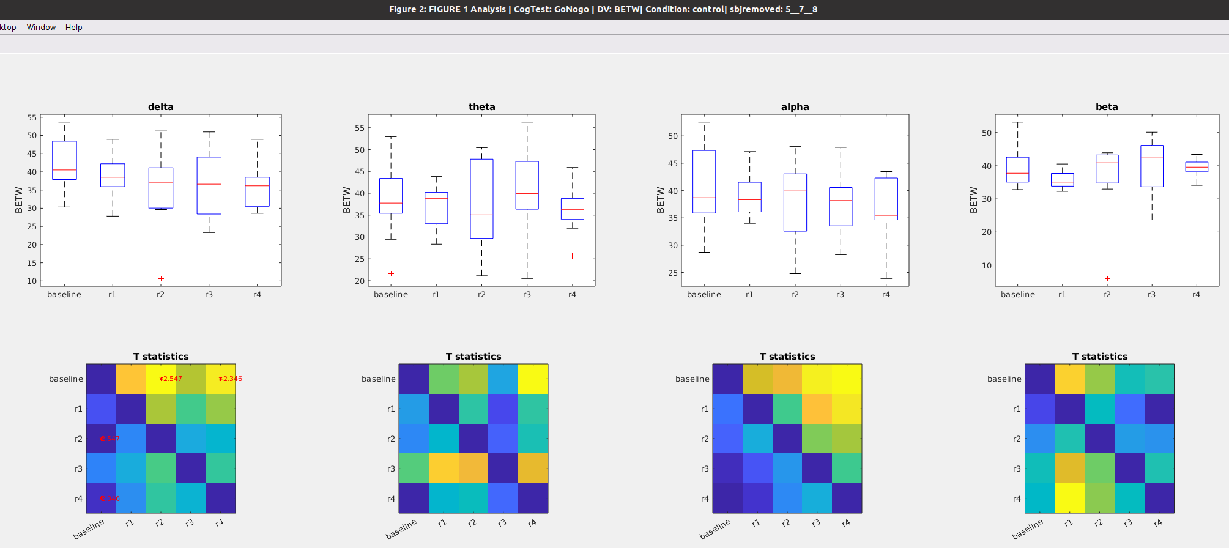

### Figure 16b: Time course of **Betweenness** after awakening **WITH blue light exposure**

Notes

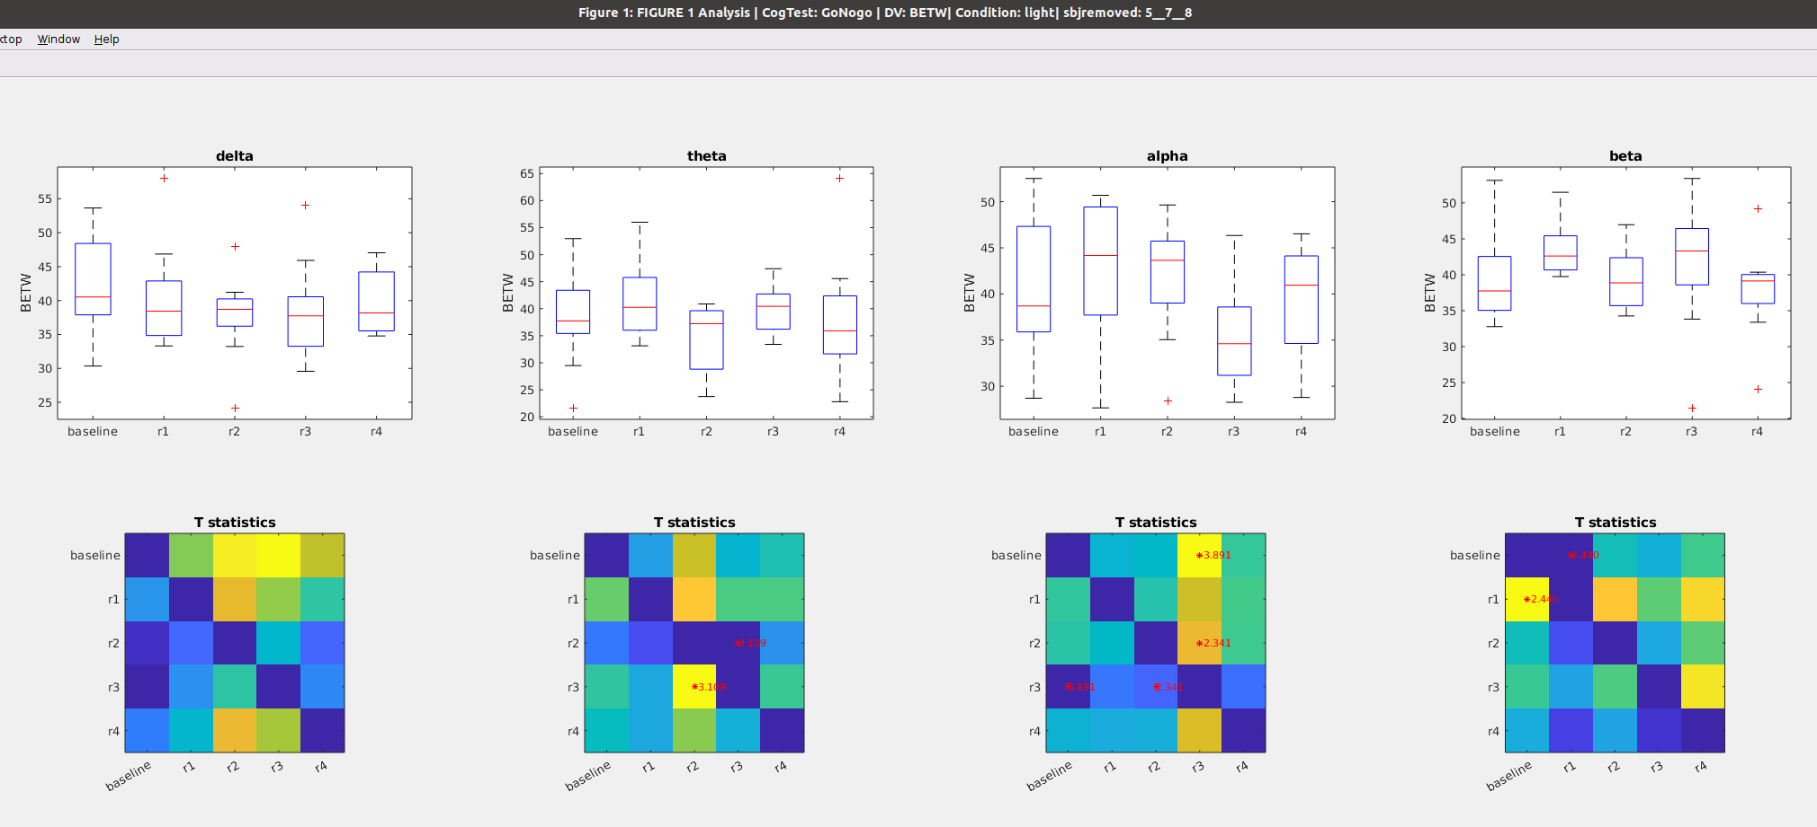

￼￼￼

## WPLI during GoNogo Task

### Figure 17a: Time course of **WPLI** after awakening **WITHOUT** blue light exposure

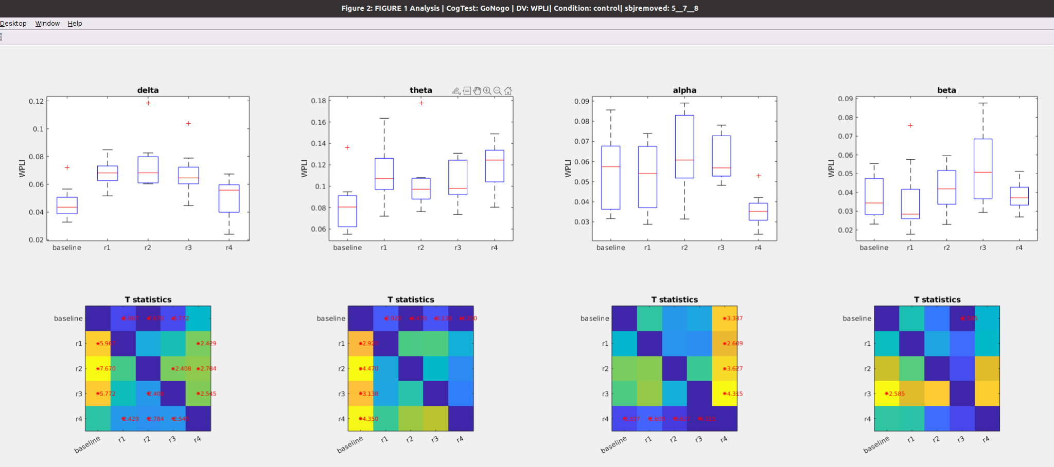

### Figure 17b: Time course of **WPLI** after awakening **WITH** blue light exposure

